Atomica Corp. EOI-
Operation of PROBE08 (Accretech UF200R) and PROBE02 (Electroglas 2001X) Version: 4.0



Title: Operation of PROBE08 (Accretech UF200R) and PROBE02 (Electroglas 2001X): Operation and Tips

Document type:

Document ID: EOI
Author:
Owner:

Approver(s):
Approval date:
Effective date:
Next periodic review date:

Atomica Corp. EOI-249
Operation of PROBE08 (Accretech UF200R) and PROBE02 (Electroglas 2001X) Version: 4.0

Purpose
The purpose of this document is to provide instructions for operating PROBE08, the Accretech UF200R Fully Automatic Prober installed in Bay 12.

Scope

  - This procedure is designed for any personnel using the Accretech UF200R to probe wafers.
  - Compliance to a specification is not part of this document.
  - Project specific instructions are not part of this document.

References

  - SOP-17 Manufacturing Processes and Process Control Procedure
  - SOP-15 Control of Records
  - ECP-217 Prober Equipment Control Plan

Deﬁnitions
Table 4: Definitions of terms, acronyms, and abbreviations

Term | Deﬁnition
EMO | Emergency Off. The kill-switch button which should be pressed to cut power to the tool in the event of an emergency.
DMM | Digital Multimeter. Electronic test tool for taking precise measurements of voltage, resistance, current and capacitance.
SMU | Source Measure Unit. Electronic test tool which can source voltage/current while measuring voltage/current.

Responsibilities
  - It is the responsibility of persons operating PROBE08 to read this document.
  - It is the responsibility of the Metrology Engineer to maintain this document.
Atomica Corp. EOI-249
Operation of PROBE08 (Accretech UF200R) and PROBE02 (Electroglas 2001X) Version: 4.0

Safety

  - The Accretech UF200R contains moving parts. Be careful of motion and pinch points when working with the chuck, head stage and transfer robot.

Figure 6a: Mechanical Hazards
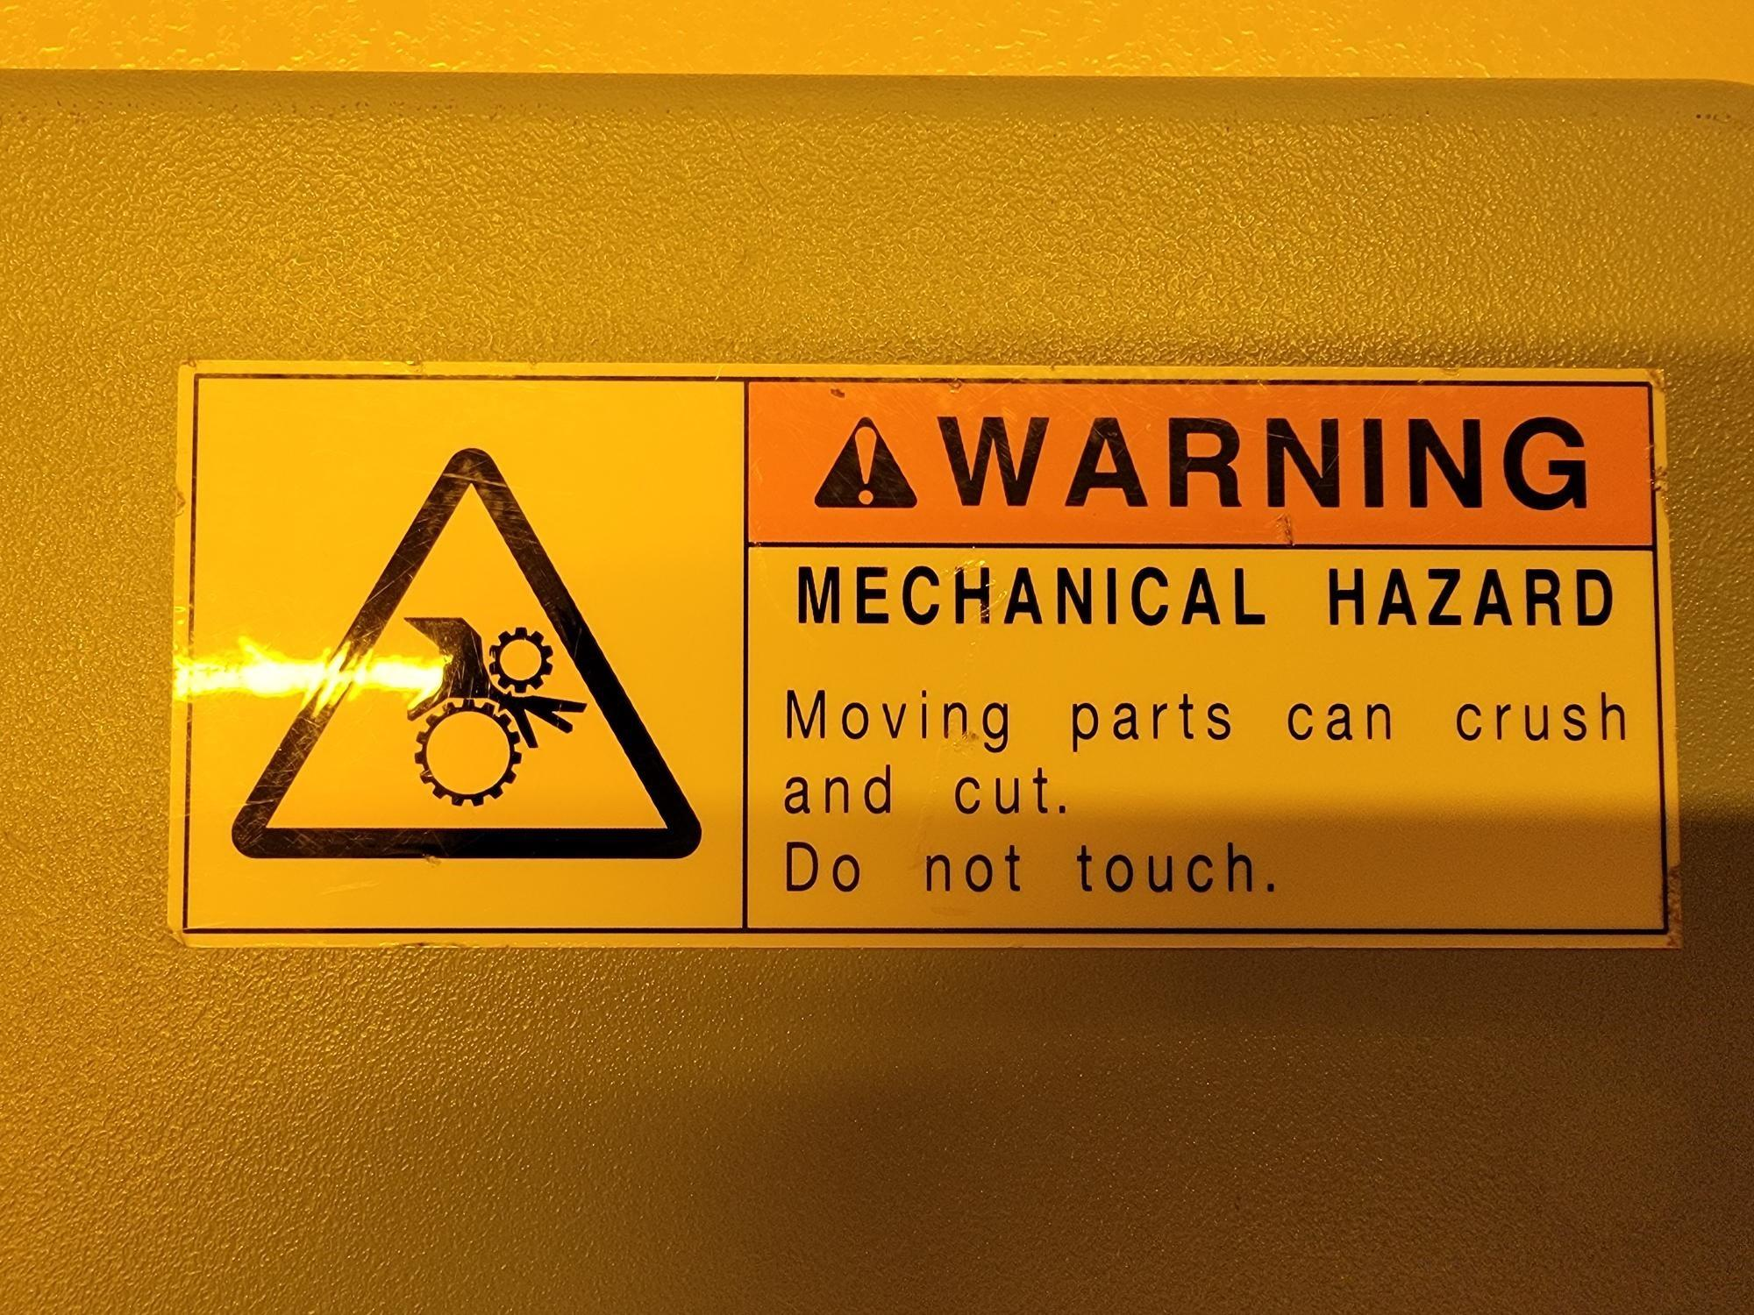
  - In the event of an emergency, press the red EMO button to stop motion and power off the tool.
Figure 6b: Emergency Off
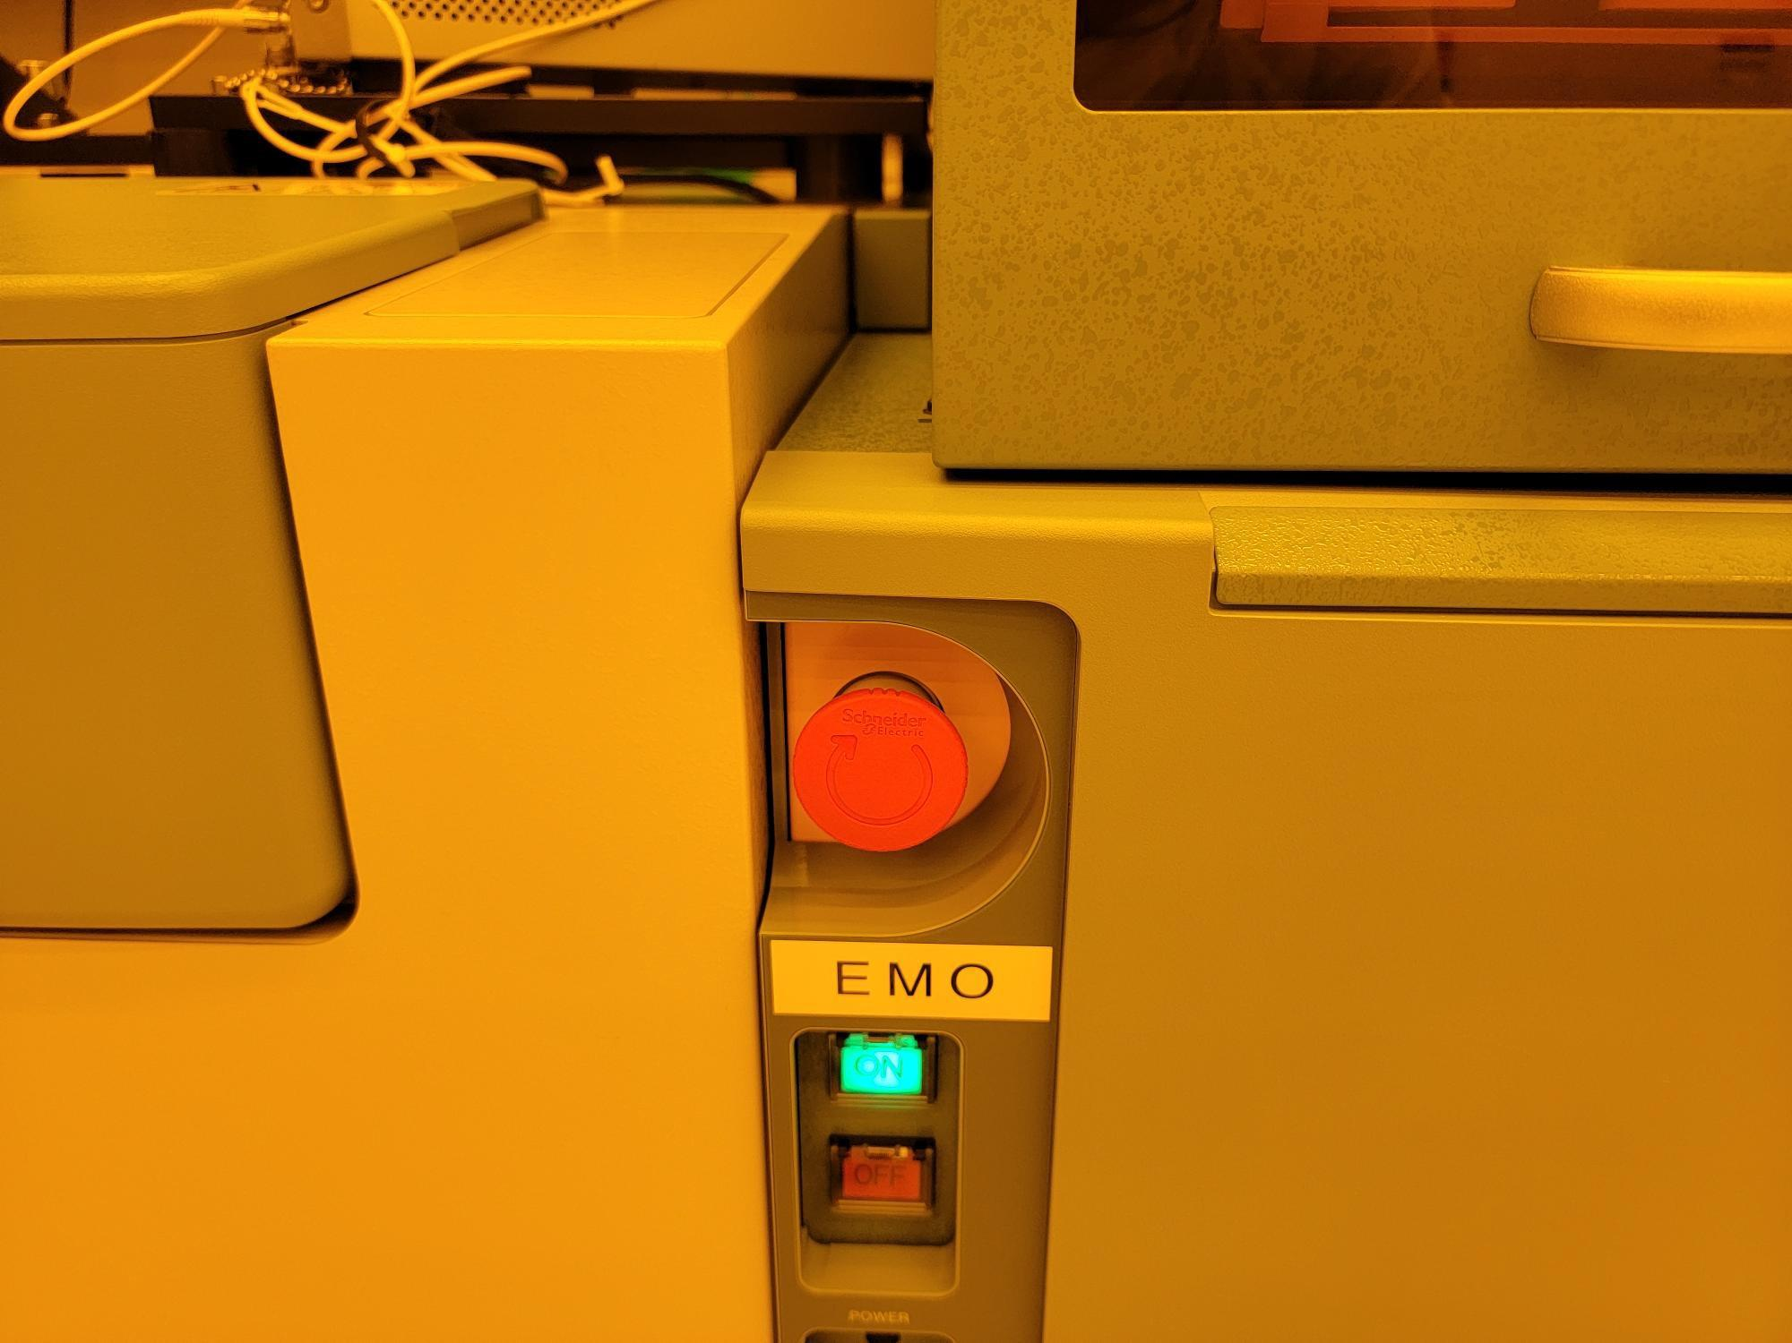
  - The cassette loader uses a Class 1 laser. Never tamper with the cassette loader lock.

Figure 6c: Laser Hazard in Cassette Loader During Operation
Atomica Corp. EOI-249
Operation of PROBE08 (Accretech UF200R) and PROBE02 (Electroglas 2001X) Version: 4.0

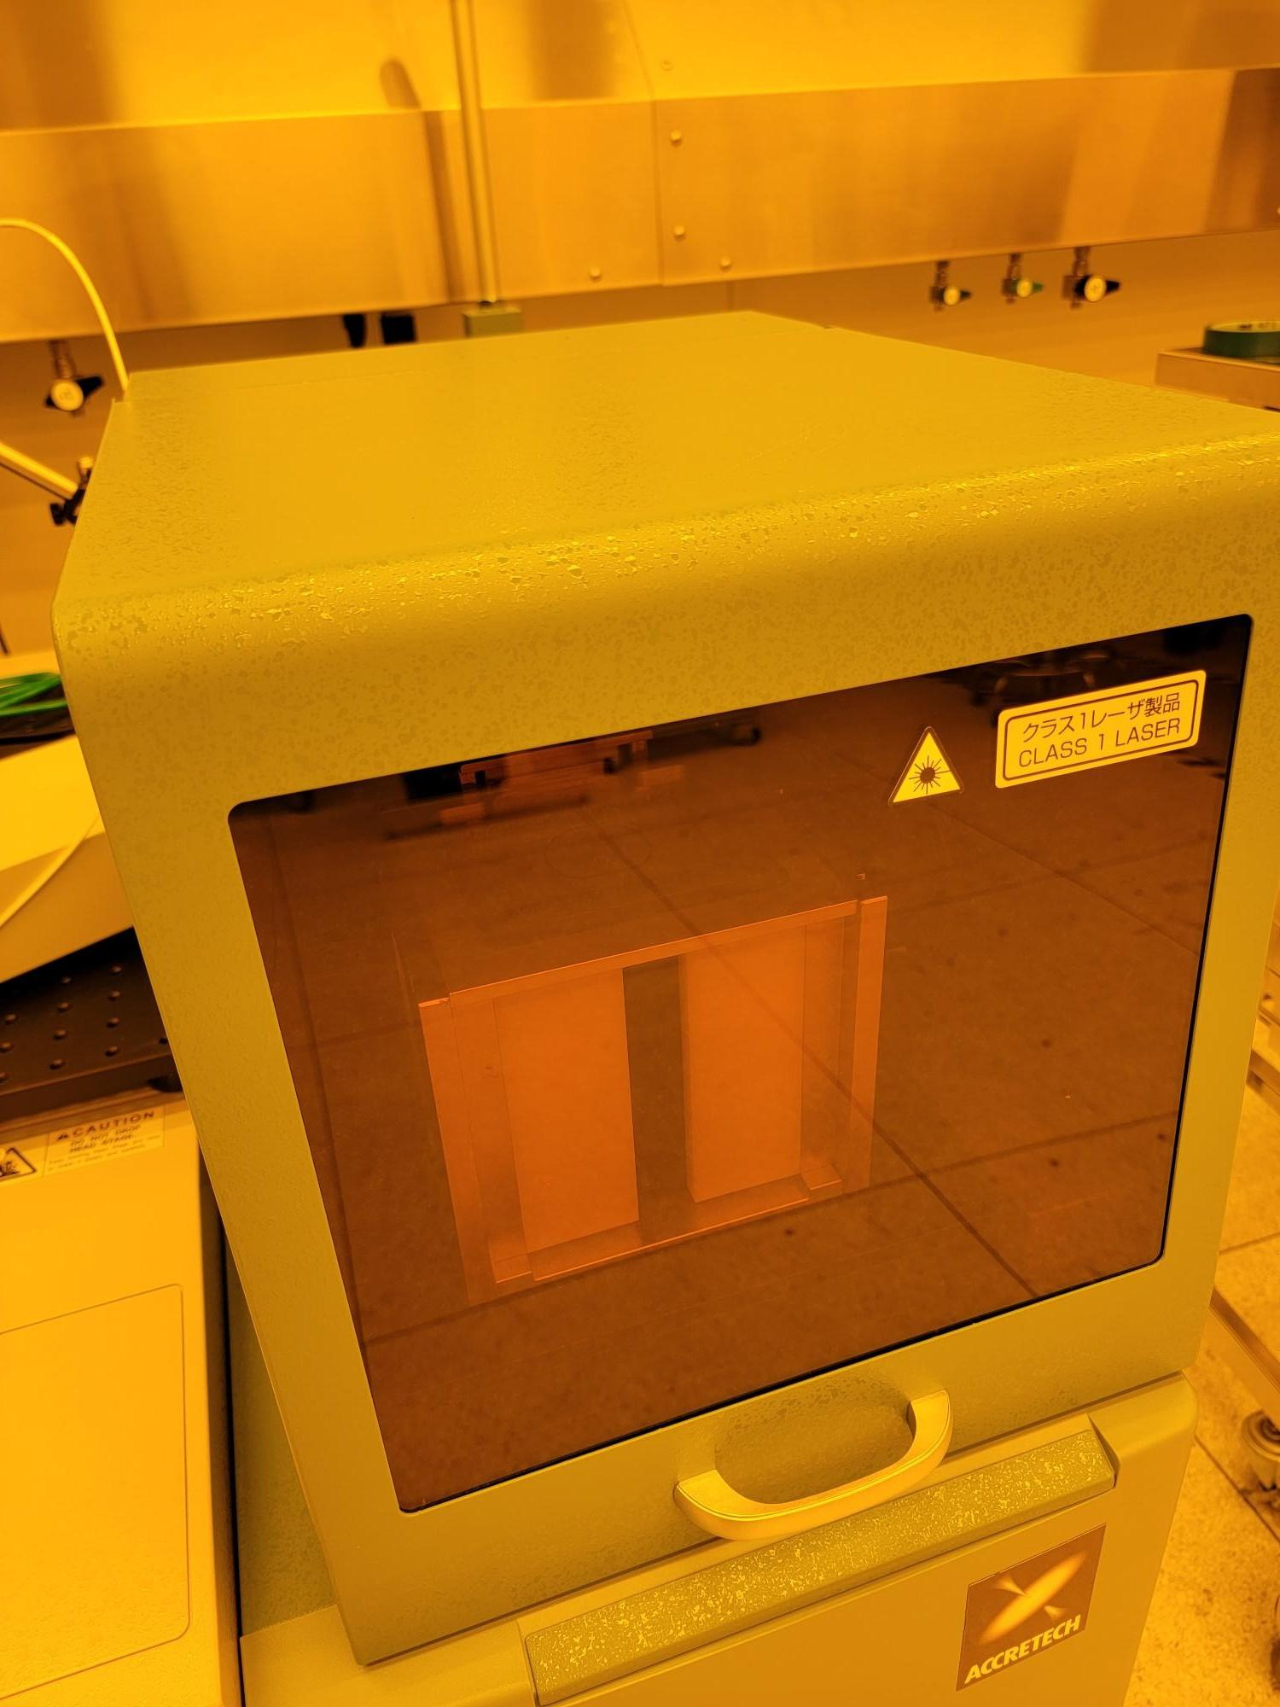

Equipment/Tooling
  - PROBE08 Accretech UF200R Fully Automatic Prober
  - KEYSIGHT 34461A Digital Multimeter
  - KEITHLEY 2636B Source Meter
  - KEYSIGHT 33500B Waveform Generator
  - Accuprobe Program-Specific Probe Cards

Procedure

Setup
    - Verify Accretech UF200R is powered on without warnings (Figure 8a).

Figure 8a: PROBE08 Powered ON
Atomica Corp. EOI-249
Operation of PROBE08 (Accretech UF200R) and PROBE02 (Electroglas 2001X) Version: 4.0

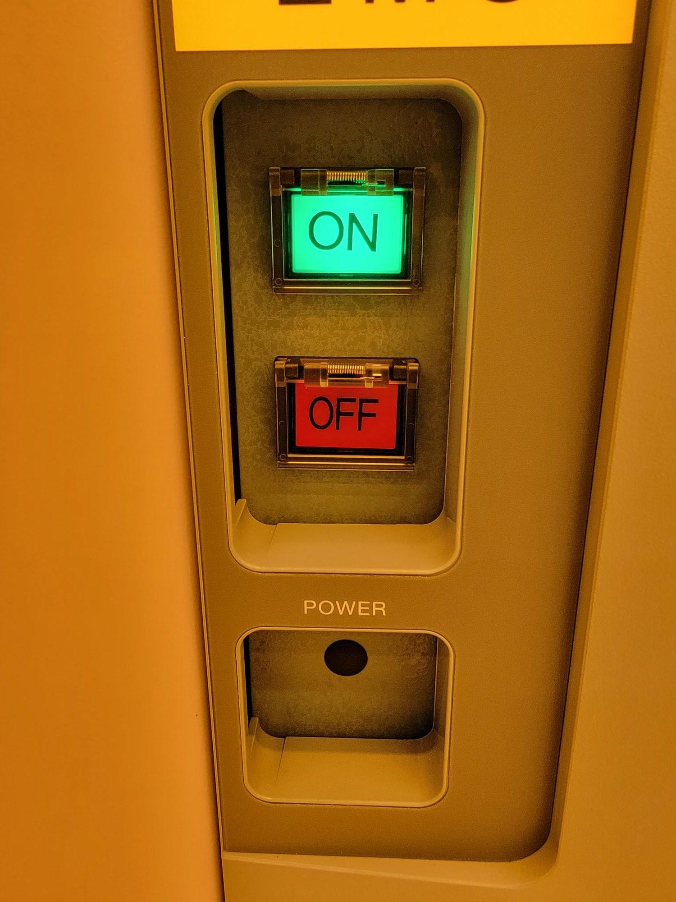
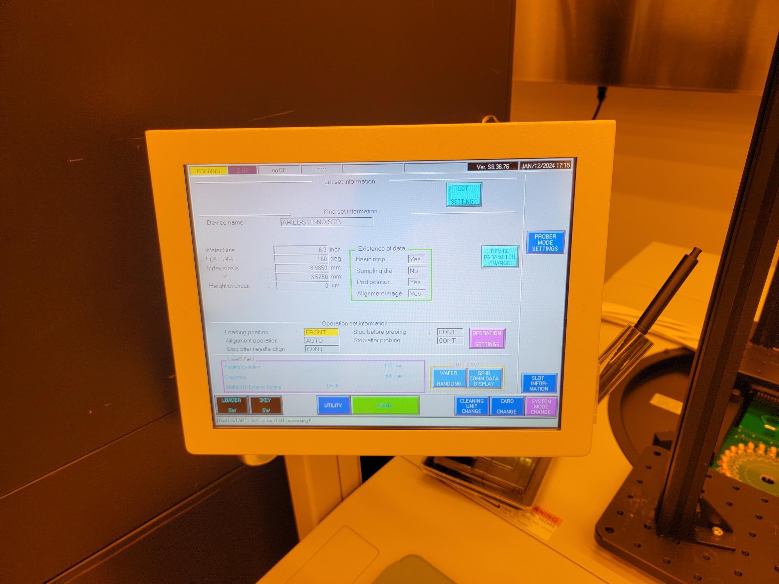

    - Verify KEYSIGHT 34461A is powered on (Figure 8b).

Figure 8b: KEYSIGHT 34461A DMM Powered ON
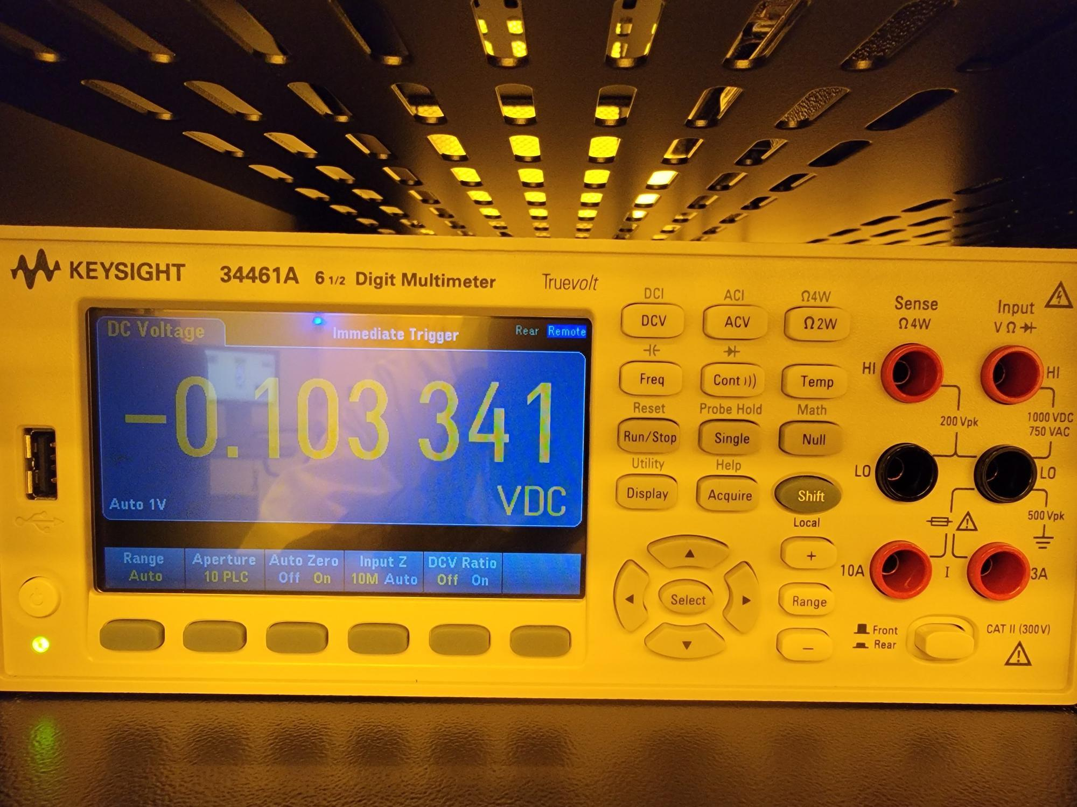
Atomica Corp. EOI-249
Operation of PROBE08 (Accretech UF200R) and PROBE02 (Electroglas 2001X) Version: 4.0

    - Verify KEITHLEY 2636B is powered on (Figure 8c).

Figure 8c: KEITHLEY 2636B SMU Powered ON
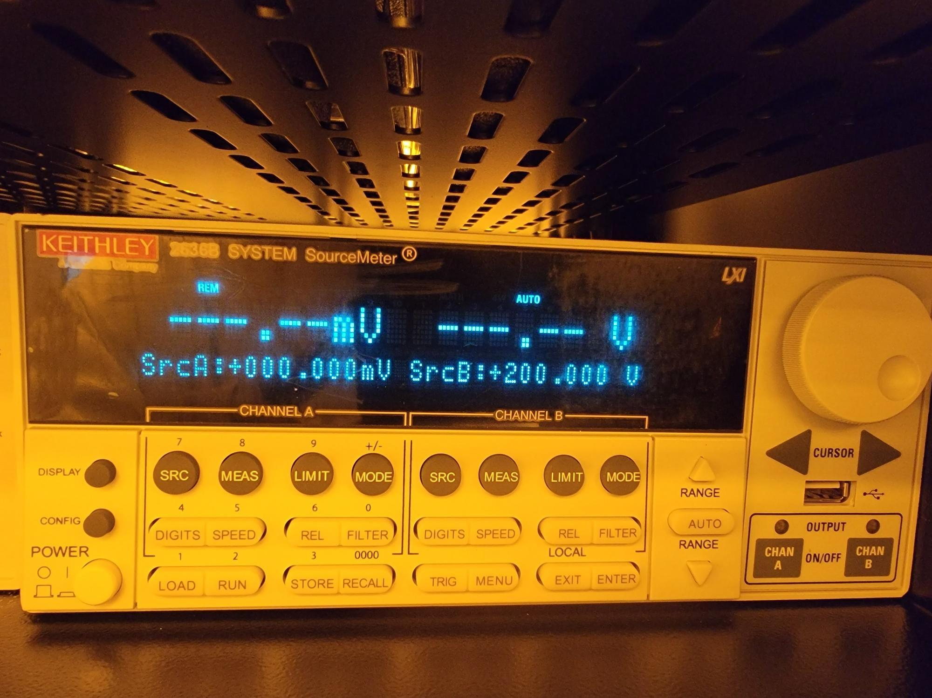
    - Verify KEYSIGHT 33500B is powered on (Figure 8d).
Figure 8d: KEYSIGHT 33500B Function Generator Powered ON
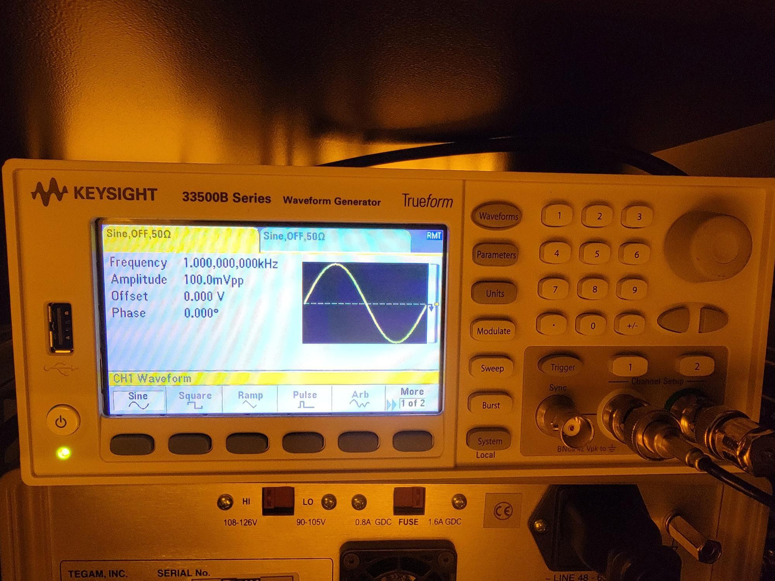
    - You can also check all instruments by opening the GUI and verifying the green checkmarks on the left.
Figure 8e: Instrument Connections
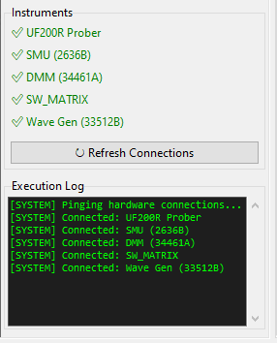

Changing Probe Card
    - Within the main production screen, press “CARD CHANGE” (Figure 8e).

Figure 8e: CARD CHANGE
Atomica Corp. EOI-249
Operation of PROBE08 (Accretech UF200R) and PROBE02 (Electroglas 2001X) Version: 4.0

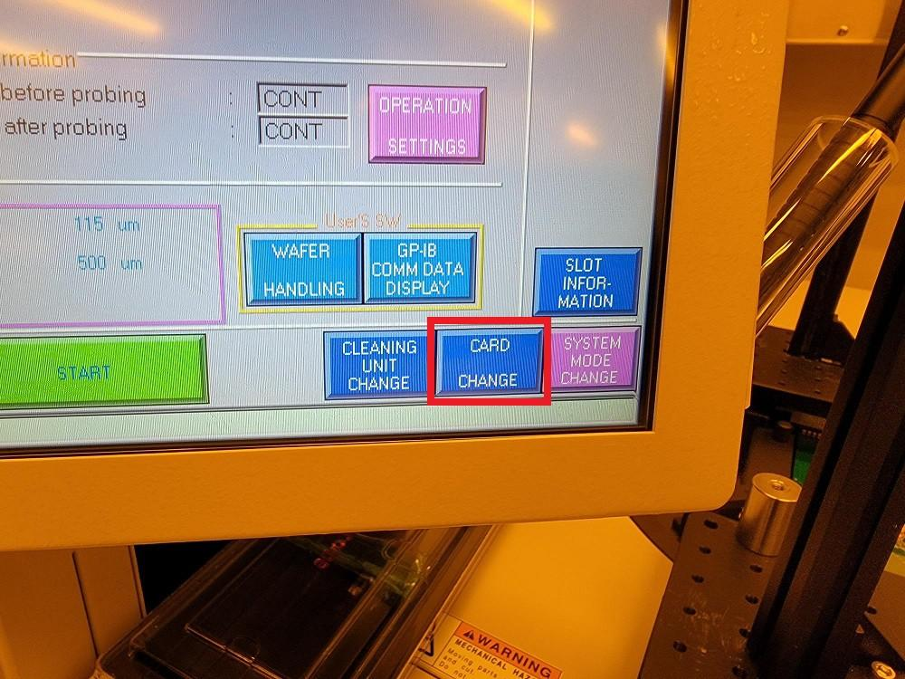
    - Press “CARD CHANGE START” (Figure 8f).

Figure 8f: CARD CHANGE START
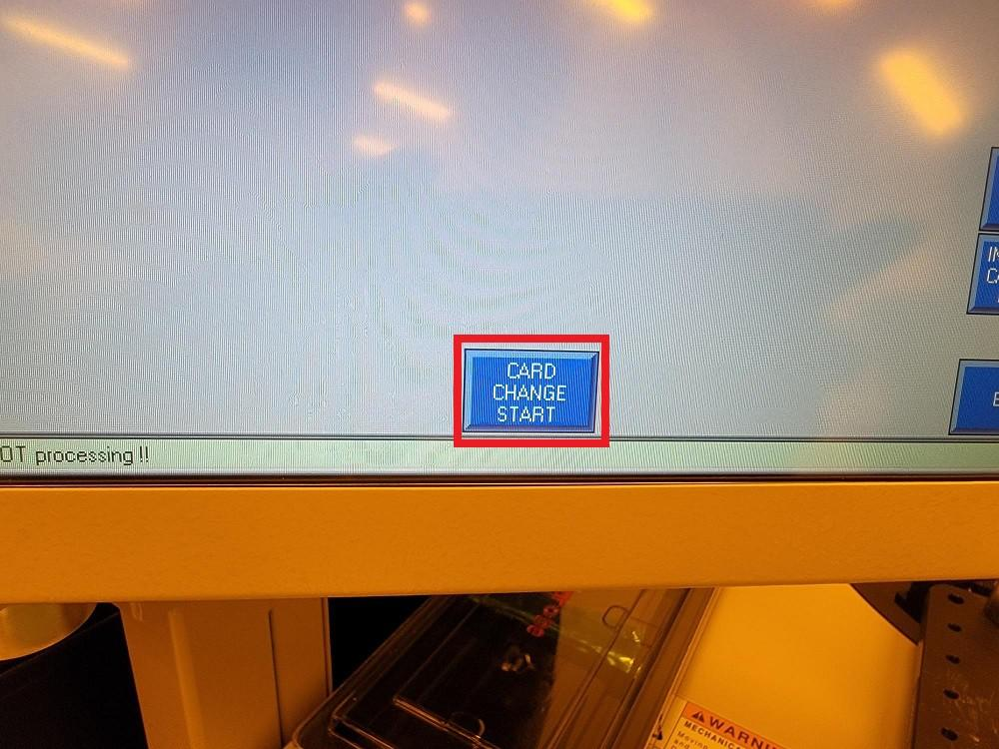
    - Loosen (4) thumb screws and open clamps (Figure 8g).

Figure 8g: Loosen Screws and Open Clamps
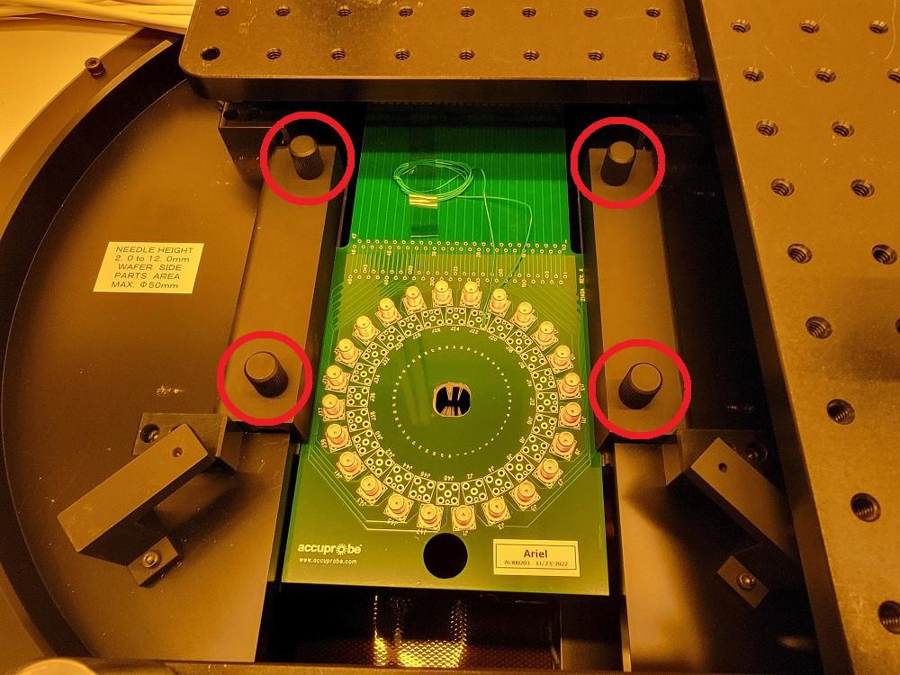
Atomica Corp. EOI-249
Operation of PROBE08 (Accretech UF200R) and PROBE02 (Electroglas 2001X) Version: 4.0

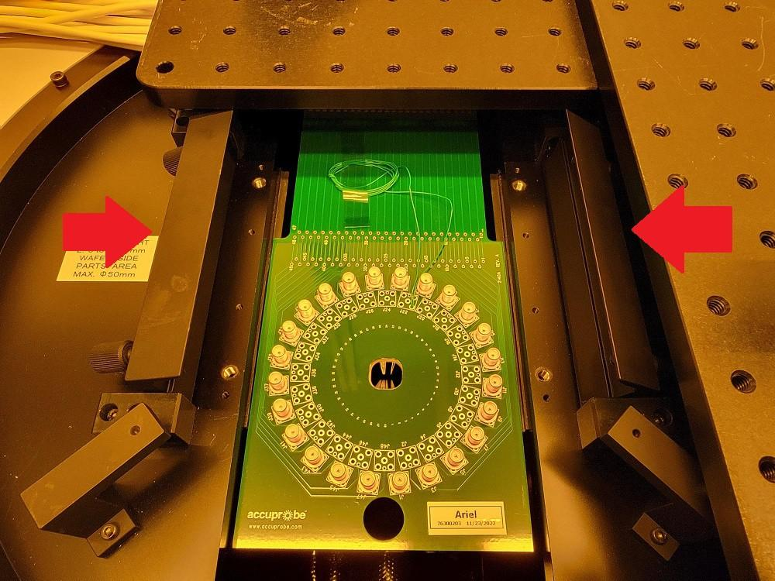
    - Use the hole at the front edge of the probe card to carefully pull the probe card out of the connector socket and remove the probe card (Figure 8h).

WARNING: Be very careful to avoid damaging the probe needles on the bottom of the probe card.

Figure 8h: Slide Probe Card Out of Edge Connector Socket
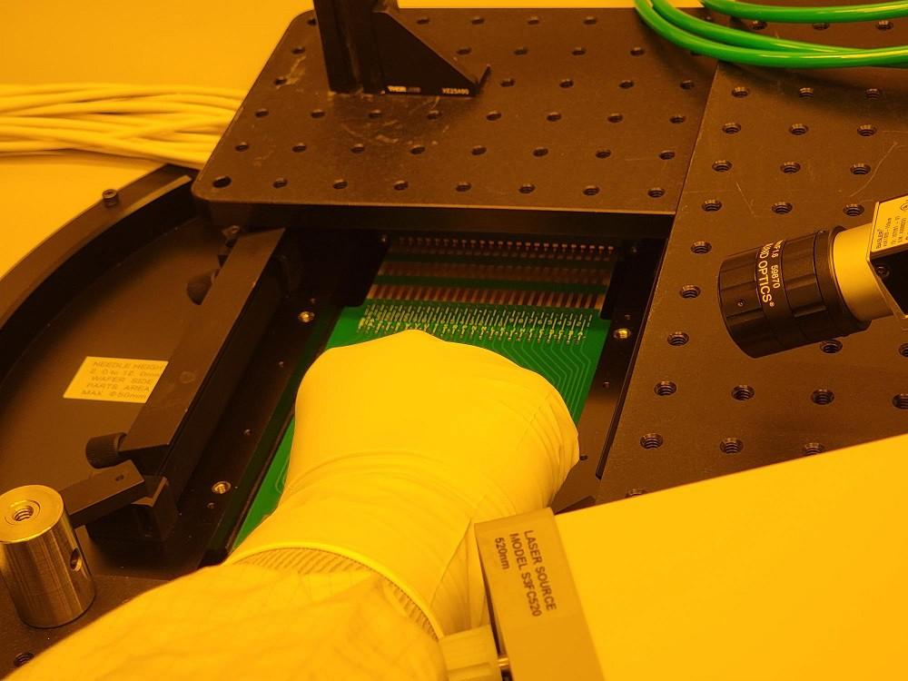
    - On the bottom of the probe card, carefully place the plastic probe needle cover over the probe needles and make sure it is secured with tape (Figure 8i).

Figure 8i: Probe Needle Cover Centered Over Probe Needles
Atomica Corp. EOI-249
Operation of PROBE08 (Accretech UF200R) and PROBE02 (Electroglas 2001X) Version: 4.0

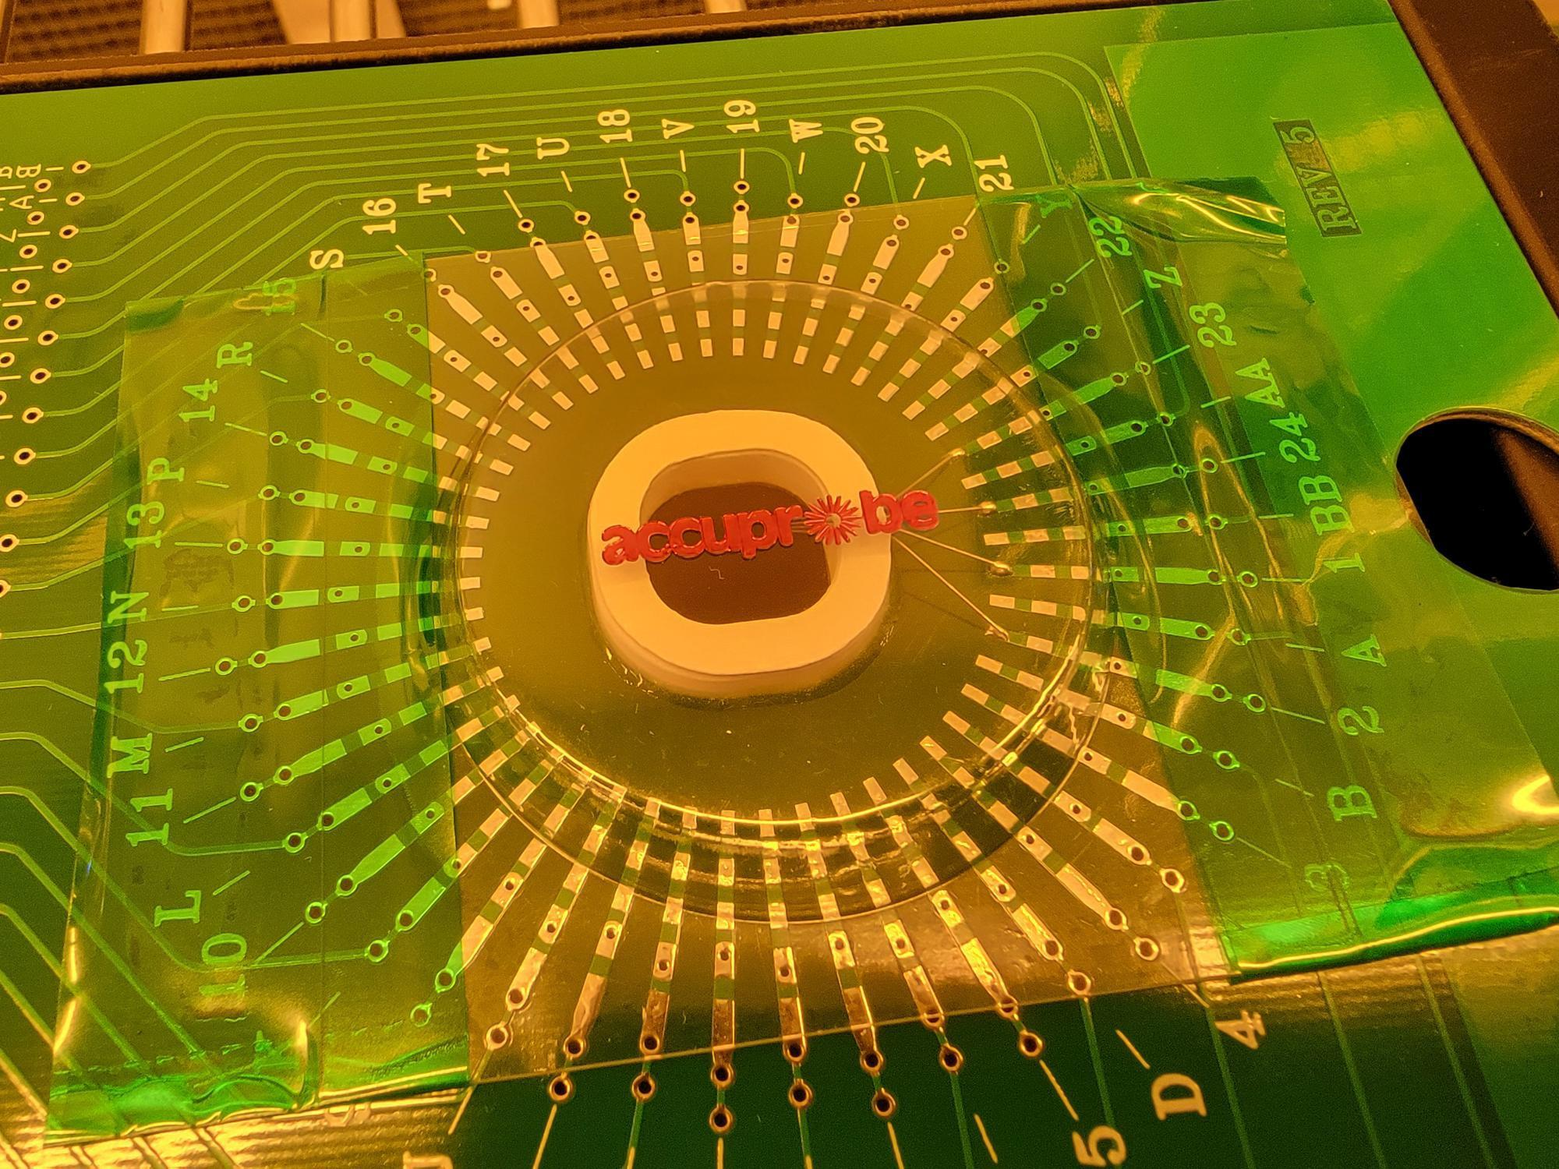
    - Store the old probe card in its case from Accuprobe on the PROBE08 rack (Figure 8j).

Figure 8j: Store Probe Cards on PROBE08 Rack
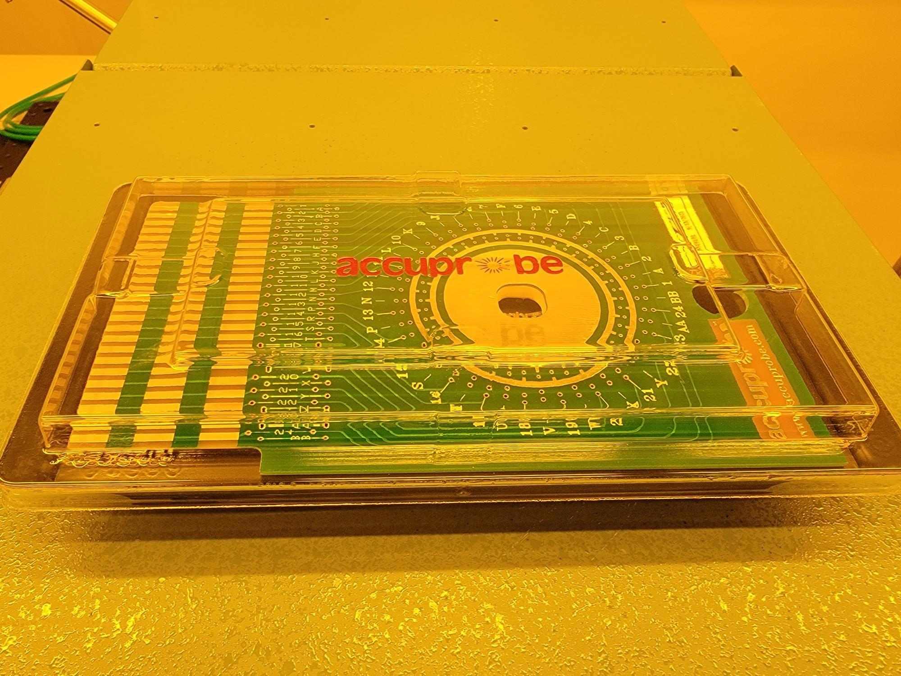
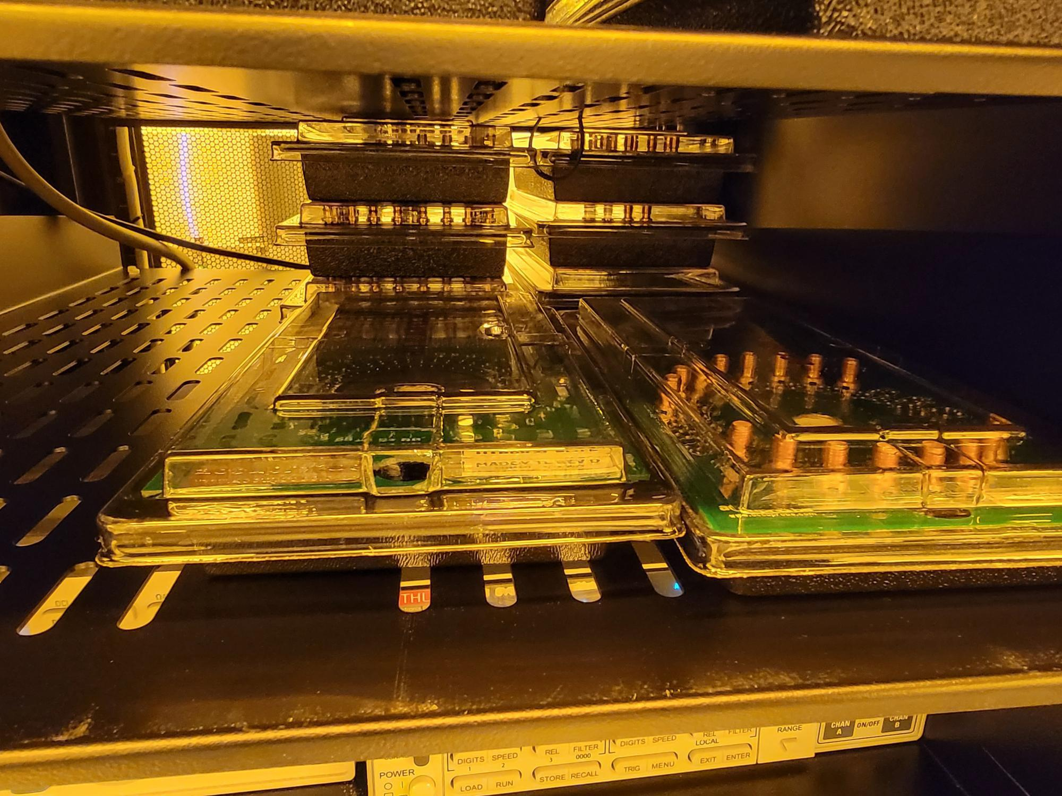

    - Carefully remove the plastic probe needle cover from the new probe card and mount it onto the stage rails so that the probe needles are pointing down. Once the new probe card is flat and centered on the rails, use the hole at the front edge of the probe card to push the probe edge connector into the socket (Figure 8k).

Figure 8k: Use Rails to Guide Probe Card Into Edge Connector Socket
Atomica Corp. EOI-249
Operation of PROBE08 (Accretech UF200R) and PROBE02 (Electroglas 2001X) Version: 4.0

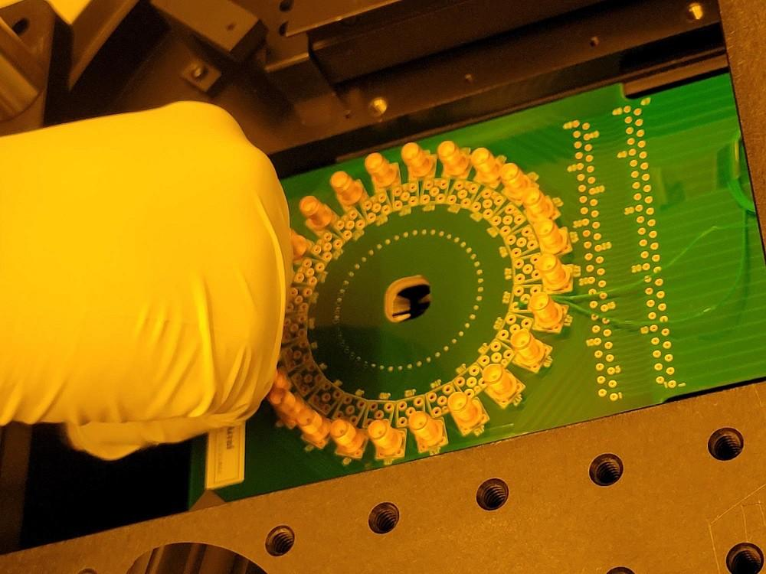
    - Bring the clamps down and tighten (4) thumb screws (Figure 8l).

Figure 8l: New Probe Card Installed
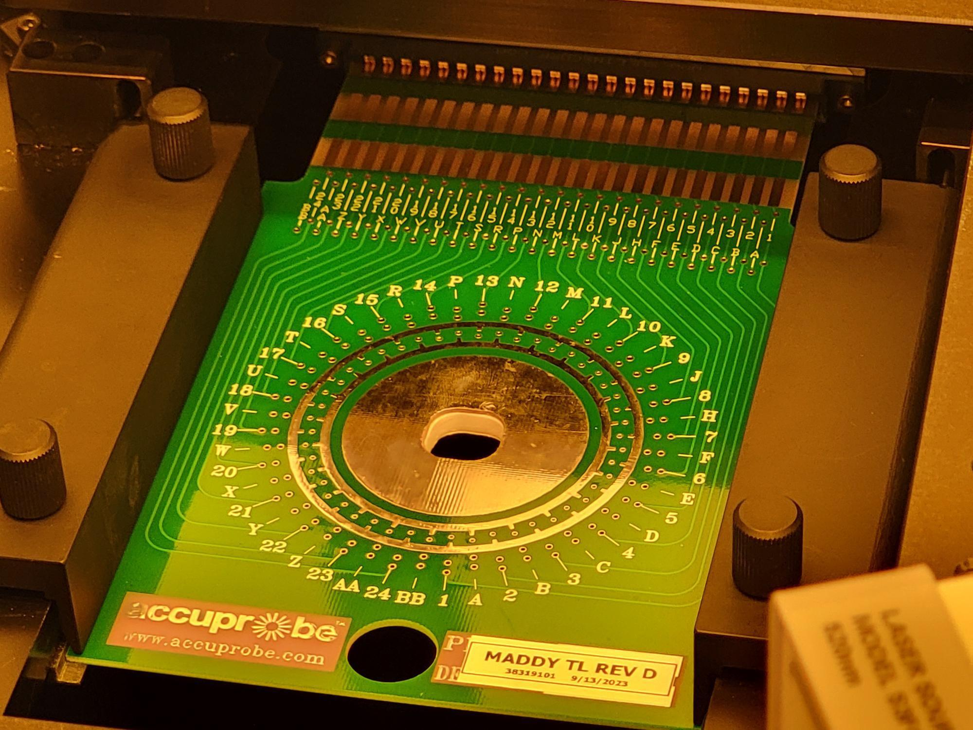
    - Press “CARD CHANGE END” (Figure 8m).

Figure 8m: CARD CHANGE END
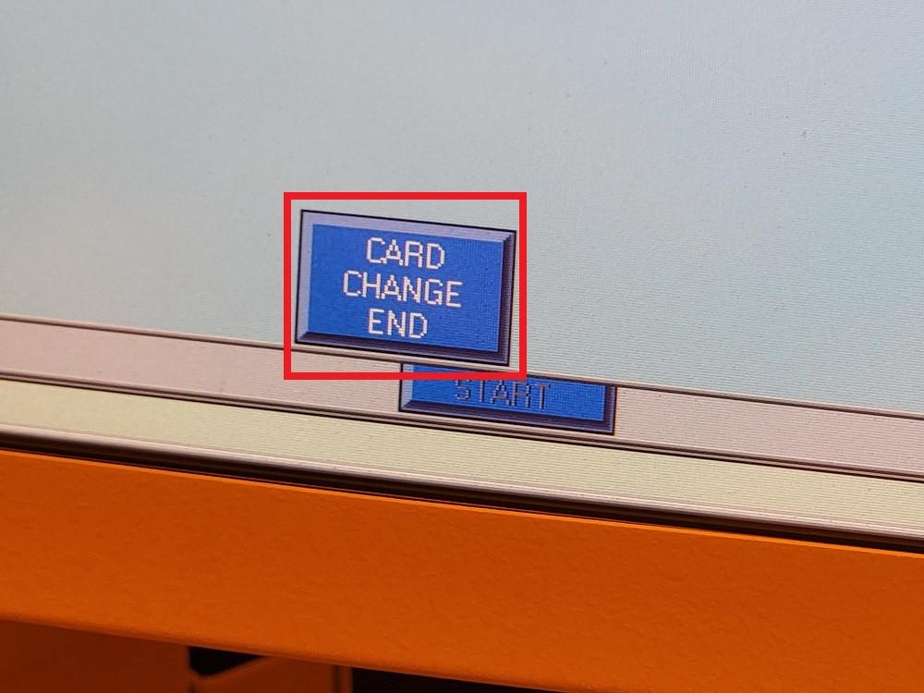
    - Press “END” (Figure 8n).

Figure 8n: END in Manual Card Change Prompt
Atomica Corp. EOI-249
Operation of PROBE08 (Accretech UF200R) and PROBE02 (Electroglas 2001X) Version: 4.0

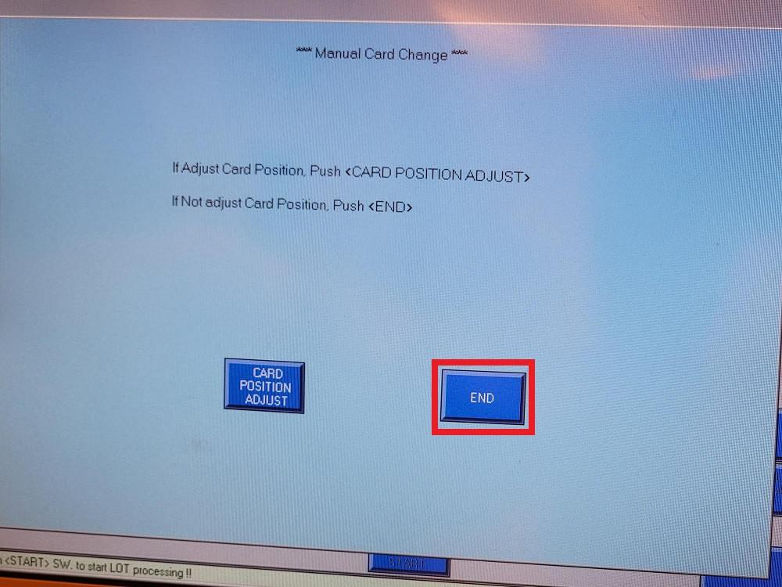
    - Press “END” (Figure 8o) to complete the probe card change and return to the main production screen.

Figure 8o: END to Complete Card Change
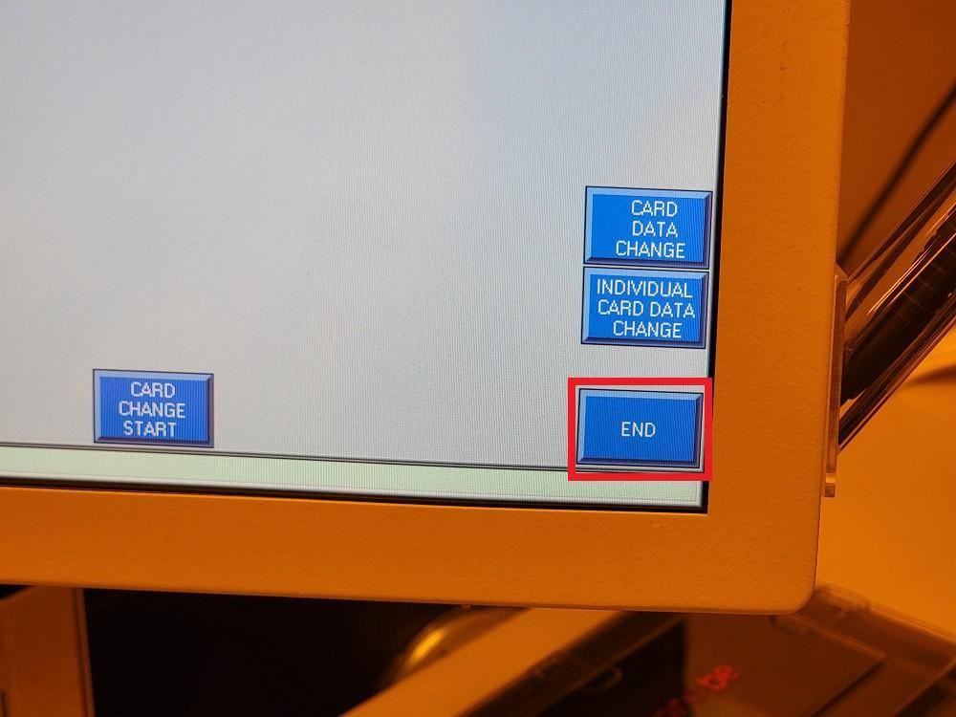
    - Next, the correct recipe for the new probe card must be loaded. Press “DEVICE PARAMETER CHANGE” (Figure 8p).

Figure 8p: DEVICE PARAMETER CHANGE
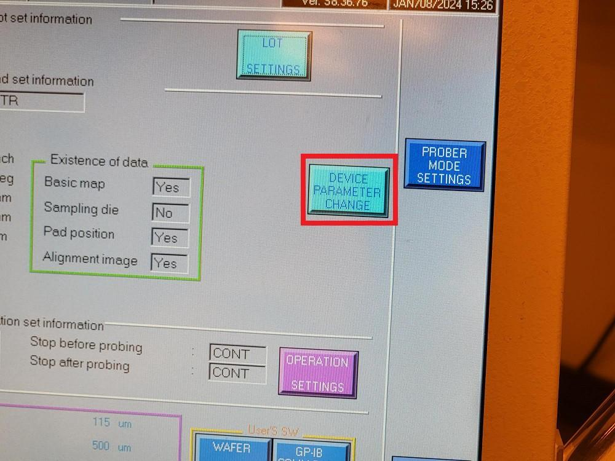
    - Press “DEVICE LIST REFERENCE” (Figure 8q).
Atomica Corp. EOI-249
Operation of PROBE08 (Accretech UF200R) and PROBE02 (Electroglas 2001X) Version: 4.0

Figure 8q: DEVICE LIST REFERENCE
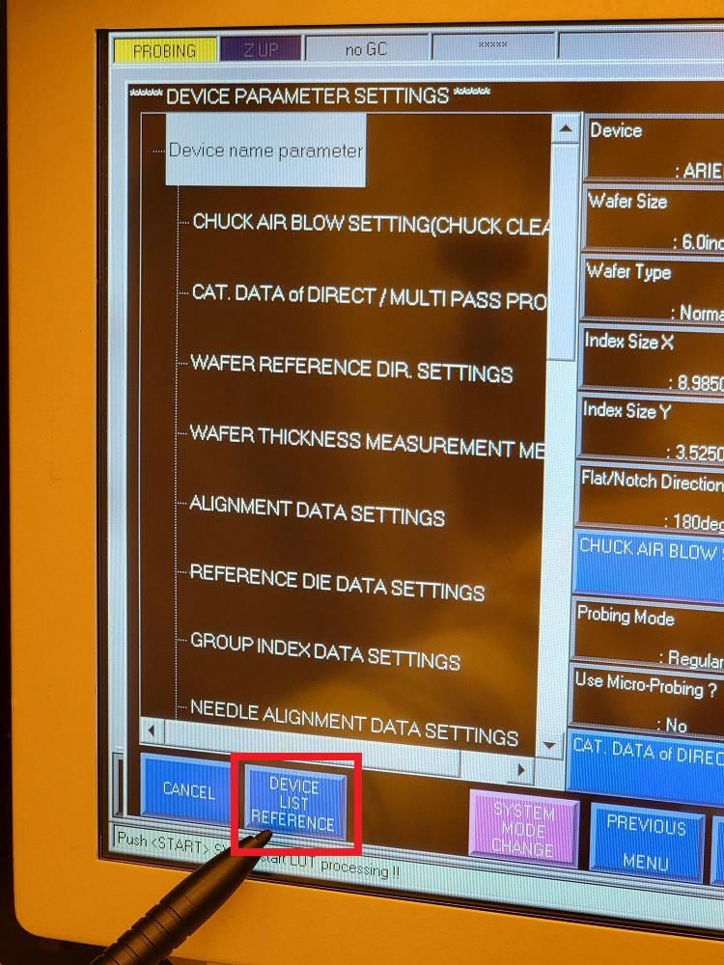
    - Verify “HD” is highlighted and press “EXECUTE” (Figure 8r).

Figure 8r: EXECUTE
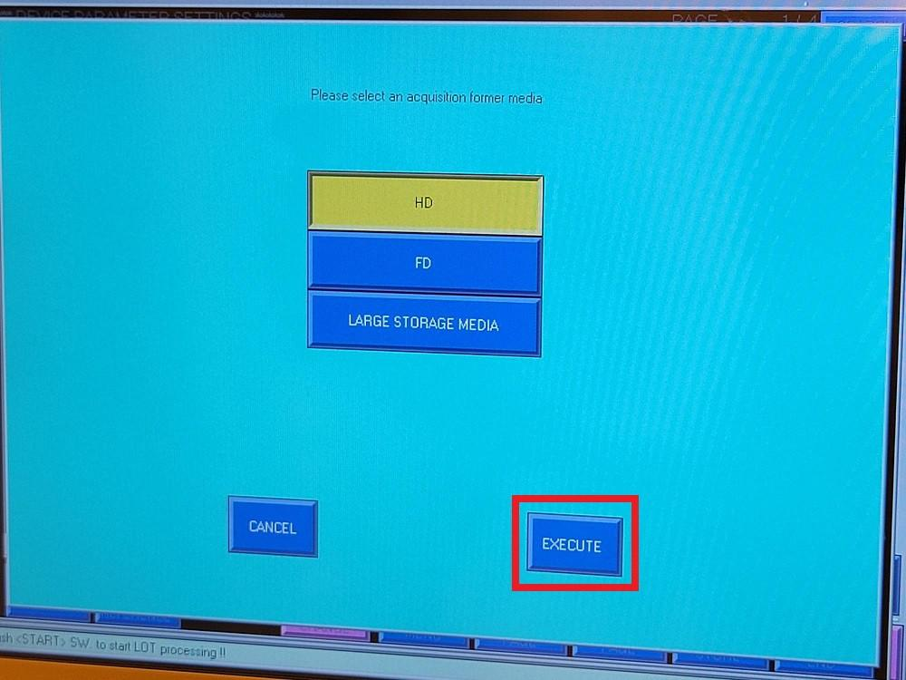
    - Select the correct recipe for the new probe card (Figure 8s).

NOTE: The recipe to use will be specified by the project team, MES or traveler.

Figure 8s: Highlight the Intended Recipe in the Device List
Atomica Corp. EOI-249
Operation of PROBE08 (Accretech UF200R) and PROBE02 (Electroglas 2001X) Version: 4.0

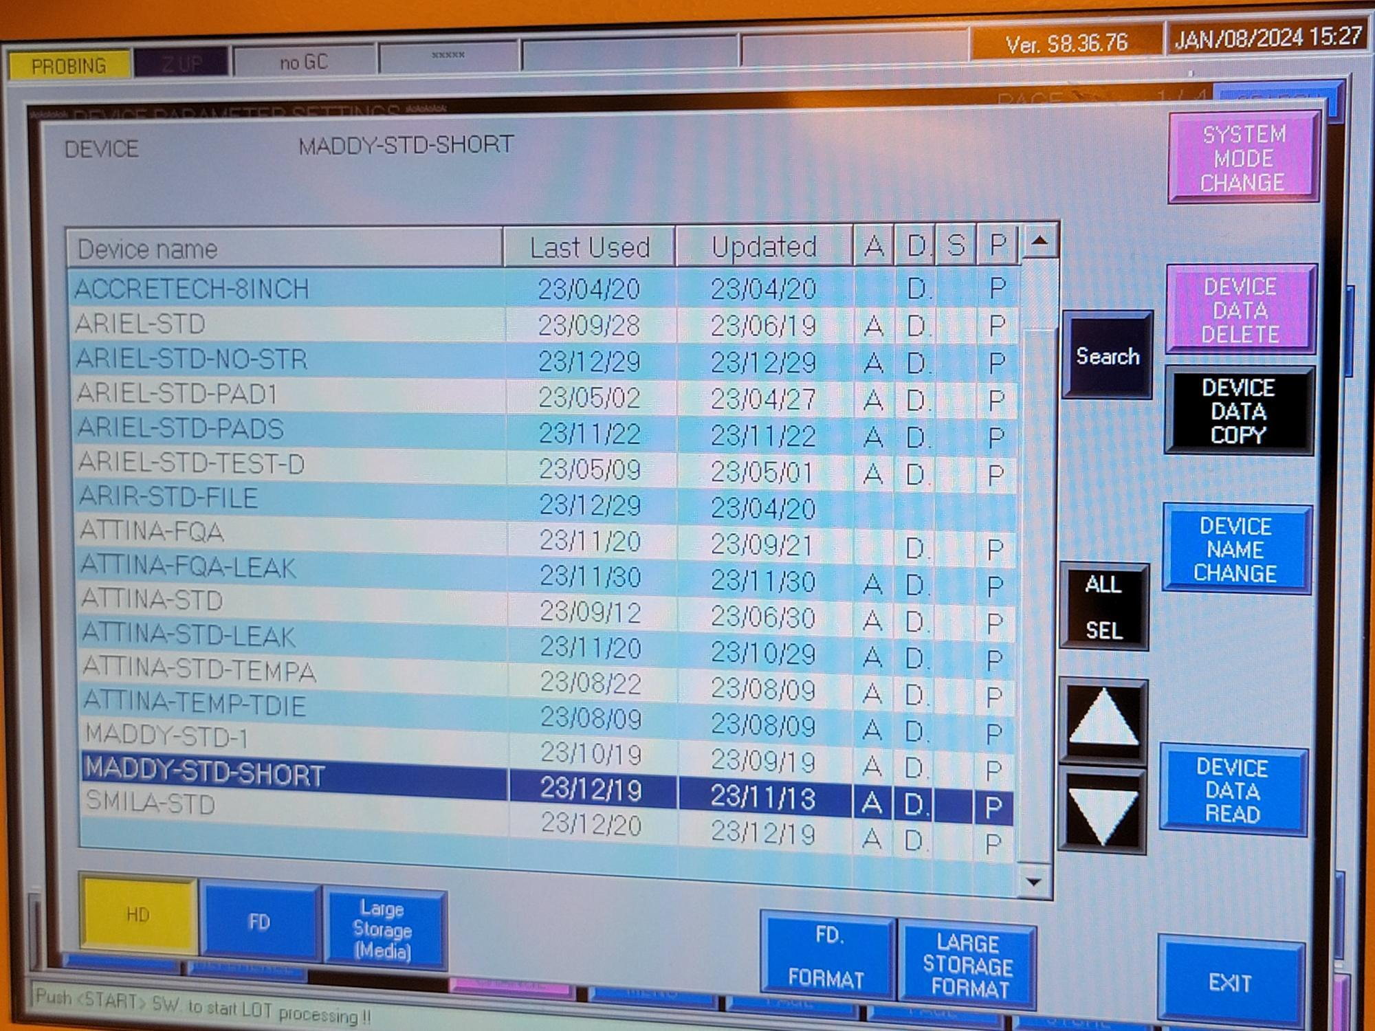
    - Press “DEVICE DATA READ” (Figure 8t).

Figure 8t: DEVICE DATA READ
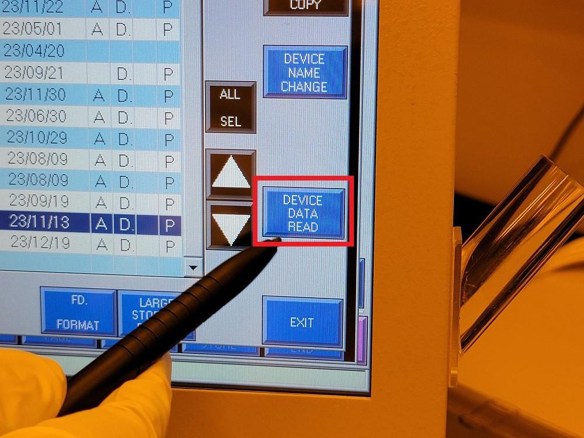
    - When prompted, press “EXECUTE” (Figure 8u).

Figure 8u: EXECUTE
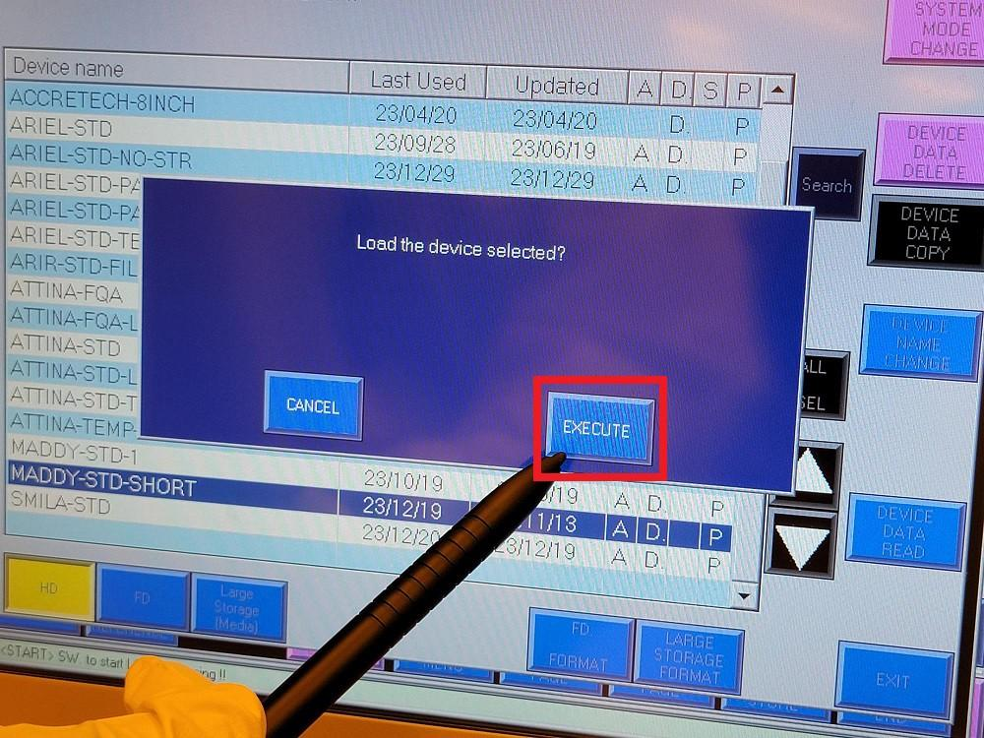
    - Press “SETTING END” (Figure 8v) to return to the main production screen.

Figure 8v: SETTING END
Atomica Corp. EOI-249
Operation of PROBE08 (Accretech UF200R) and PROBE02 (Electroglas 2001X) Version: 4.0

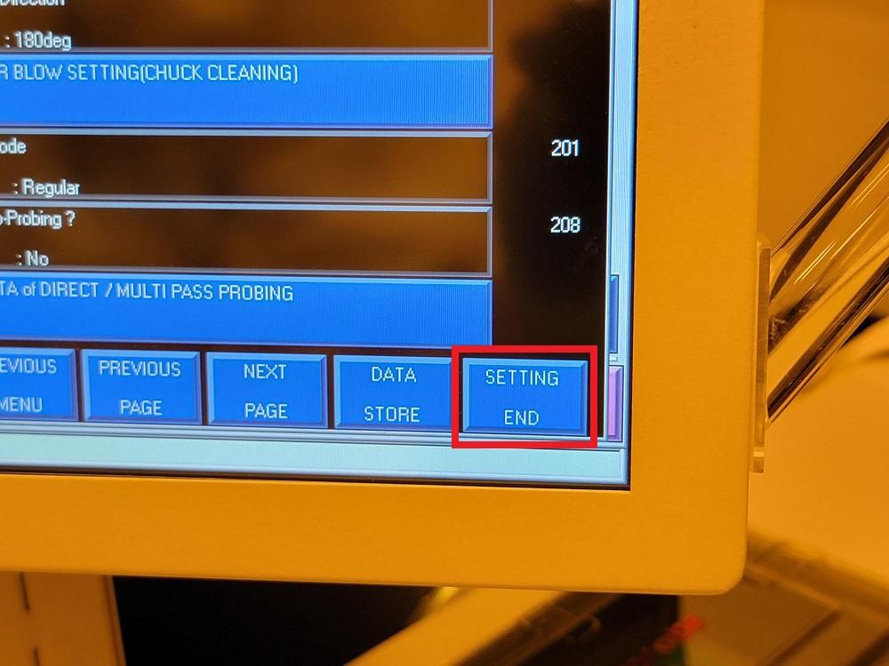

Starting Probe Routine
    - Press “OPERATION SETTINGS” (Figure 8w).

Figure 8w: OPERATION SETTINGS
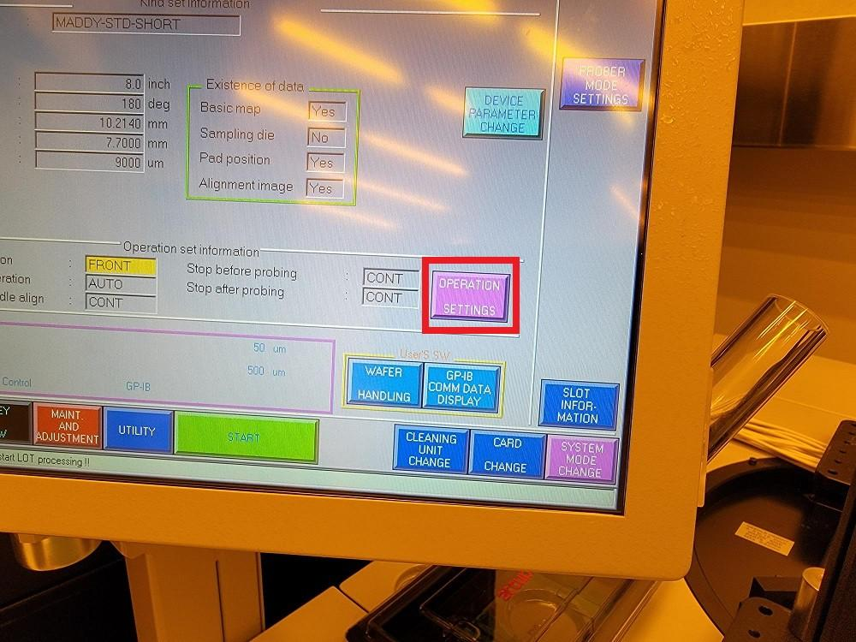
    - Verify the correct Loading/Unloading position is highlighted and press “ENT” (Figure 8x).

NOTE: The Loading/Unloading position will be program specific. 8" programs must use FRONT ACCESS DOOR and 6" programs generally use CASSETTE, although 6" wafers can be loaded using FRONT ACCESS DOOR as well. For directions on loading and unloading wafers using CASSETTE, refer to section 8.4 below.

Figure 8x: Loading/Unloading Positions
Atomica Corp. EOI-249
Operation of PROBE08 (Accretech UF200R) and PROBE02 (Electroglas 2001X) Version: 4.0

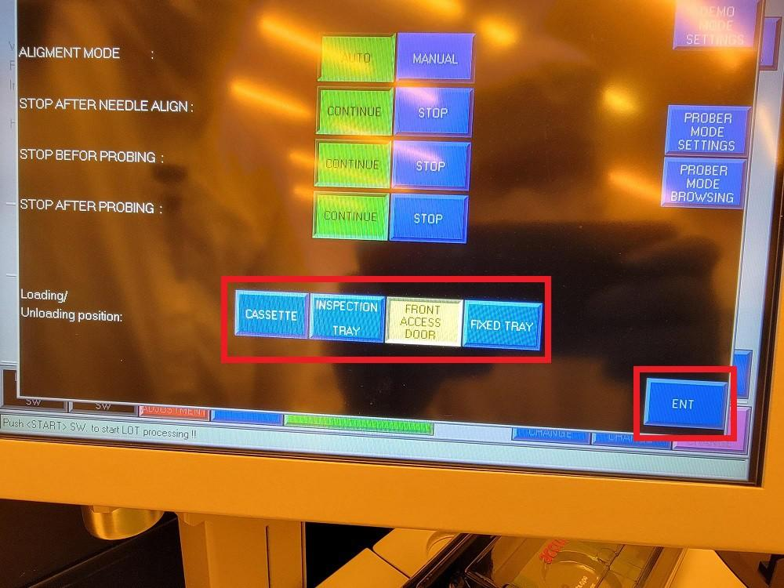
    - Press “START” (Figure 8y).

Figure 8y: START
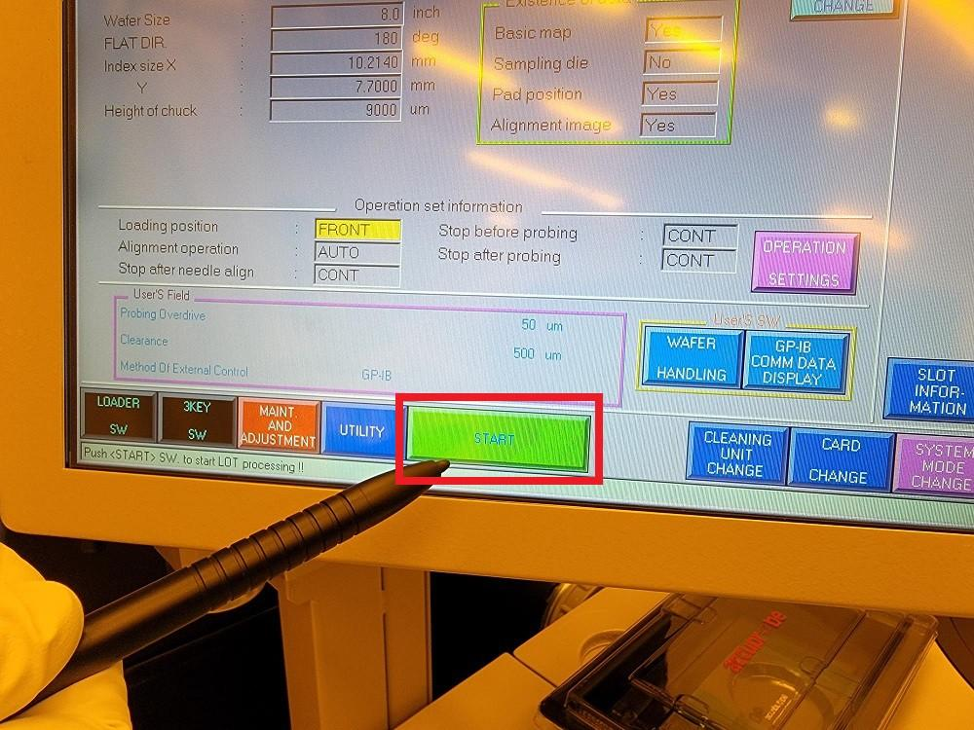
    - Press “Clear screen” when prompted with “Put wafer on CHUCK !!” (Figure 8z).

Figure 8z: Clear Screen
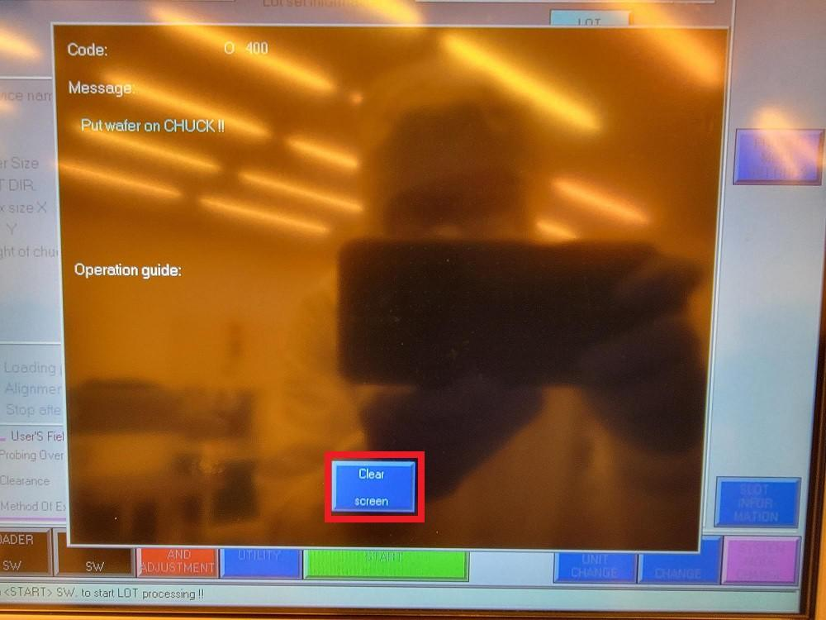
    - Open the Front Access Door (Figure 8aa).

Figure 8aa: Opening Front Access Door
Atomica Corp. EOI-249
Operation of PROBE08 (Accretech UF200R) and PROBE02 (Electroglas 2001X) Version: 4.0

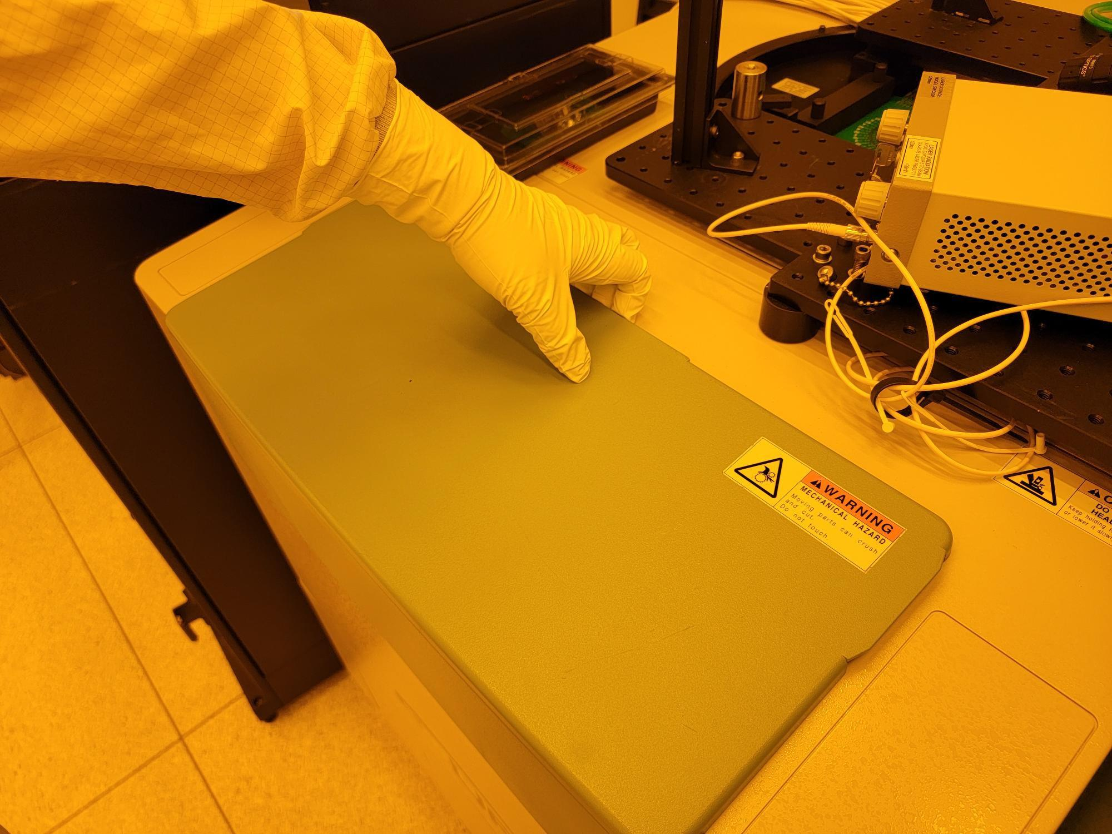
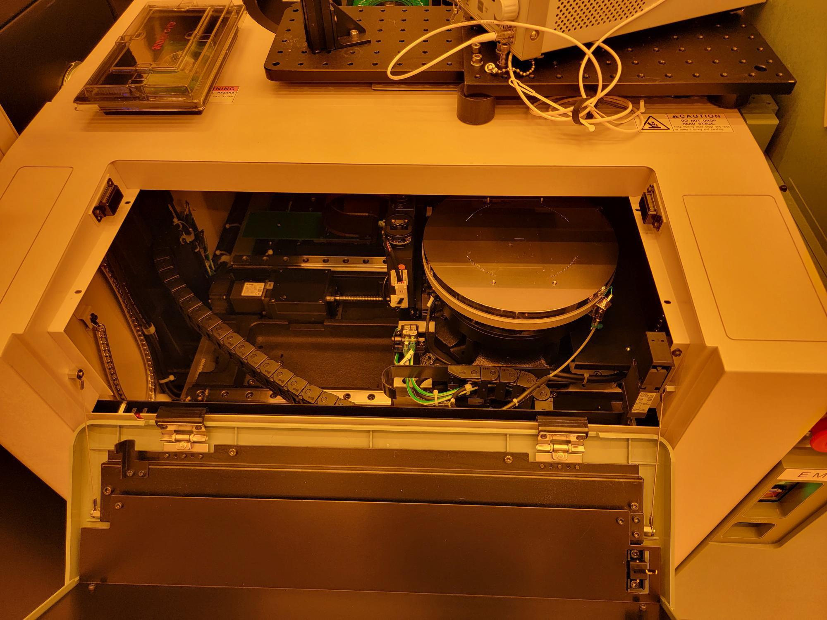

    - Load the wafer on top of the chuck pins so that the notch is aligned with the hole at 6 o'clock (Figure 8ab).

Figure 8ab: Notch Aligned with Hole at 6 O'clock
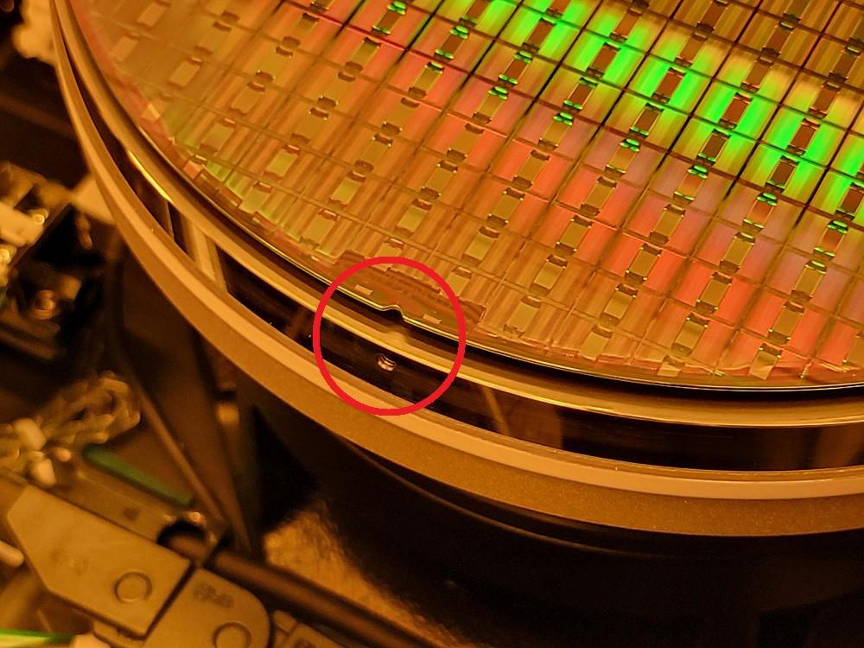
    - Close the Front Access Door.
    - Press “Start” (Figure 8ac).

Figure 8ac: START
Atomica Corp. EOI-249
Operation of PROBE08 (Accretech UF200R) and PROBE02 (Electroglas 2001X) Version: 4.0

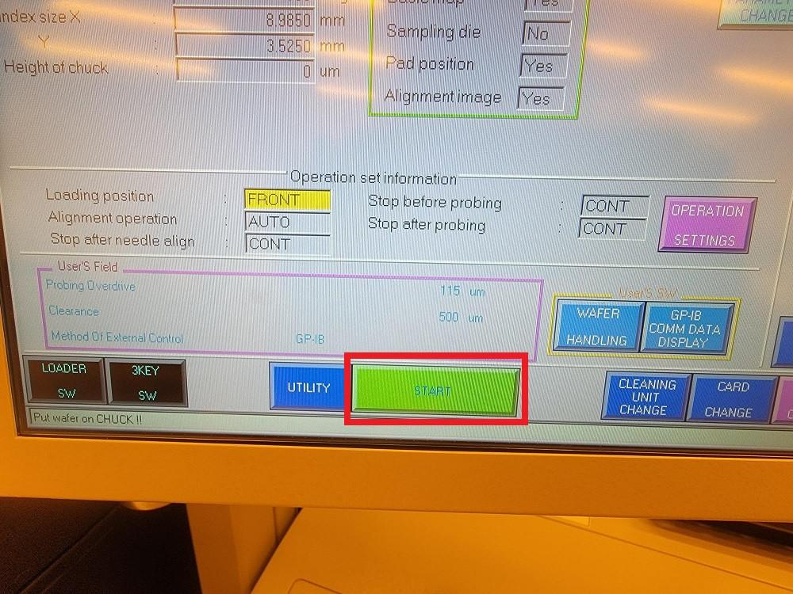
    - Press “Buzzer Release” when prompted with “NEEDLE ALIGNMENT ERROR” (Figure 8ad).

Figure 8ad: Buzzer Release
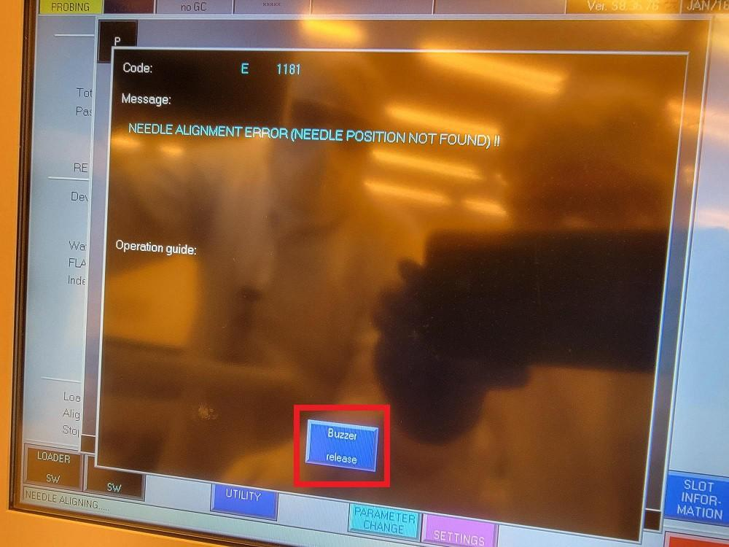
    - Press “Clear screen” when prompted with another “NEEDLE ALIGNMENT ERROR” (Figure 8ae).

Figure 8ae: Clear Screen
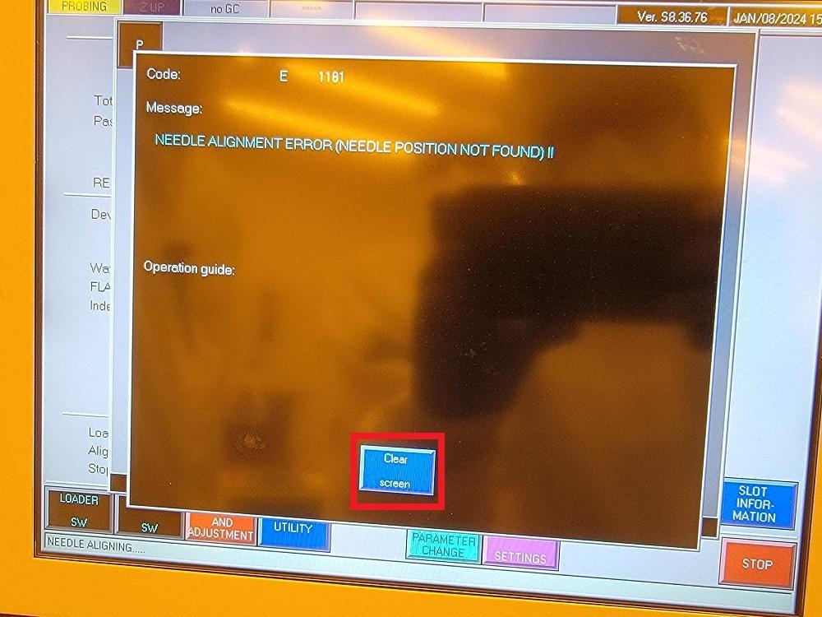
    - Press “Clear screen” when prompted with “Set CROSS MARK on needle position and push <DATA IN>” (Figure 8af).
Atomica Corp. EOI-249
Operation of PROBE08 (Accretech UF200R) and PROBE02 (Electroglas 2001X) Version: 4.0

Figure 8af: Clear Screen
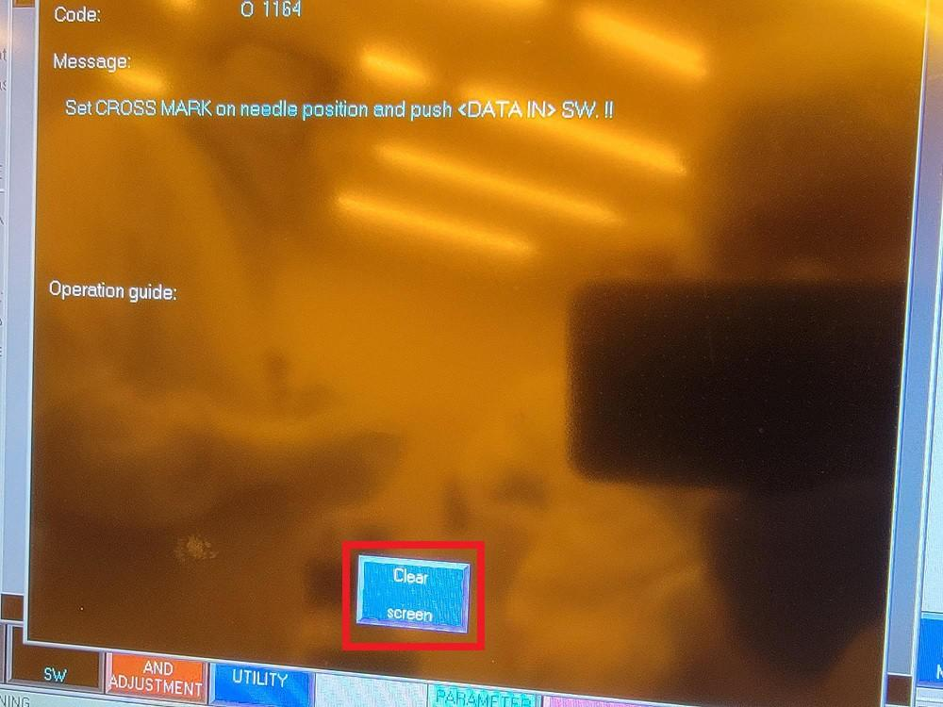
    - Press the directional arrows to jog the chuck so that the tips of the probe needles are aligned with the circles overlaying the camera feed (Figure 8ag).

NOTE: The dark green buttons can be used for fine adjustment.

Figure 8ag: Jog Chuck Until Needles Align with Circles
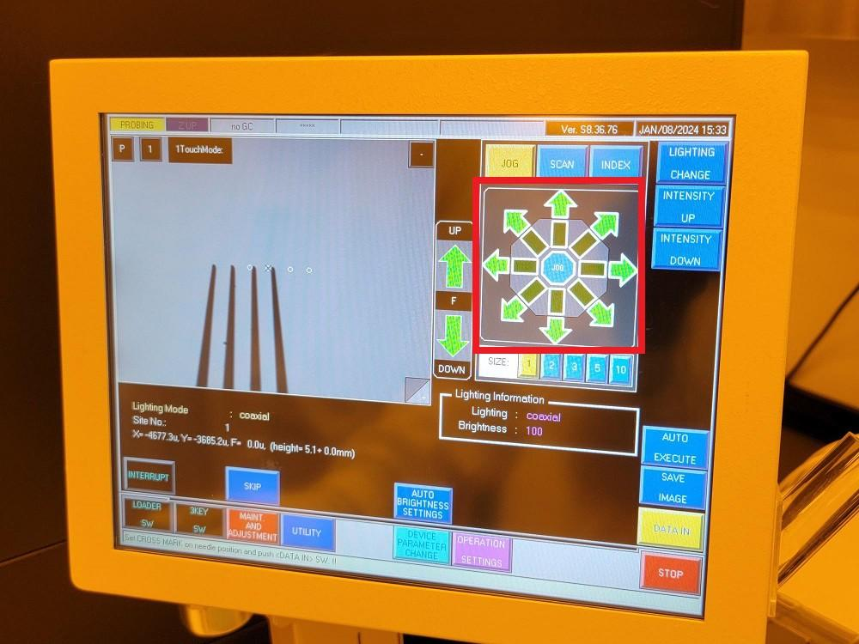
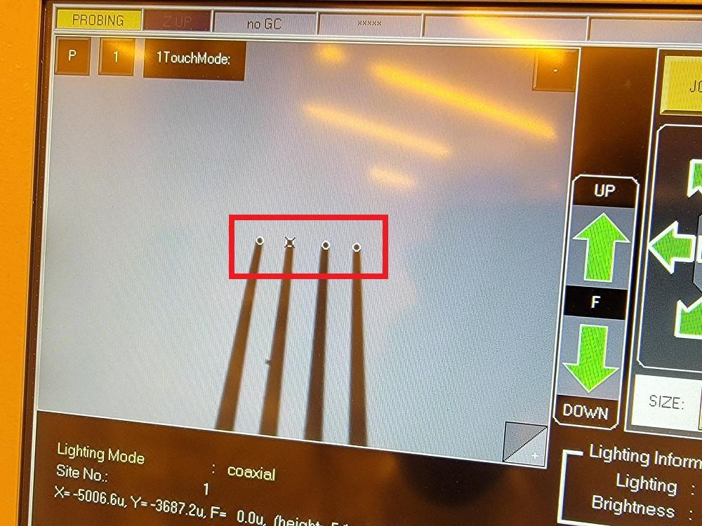

    - Press “DATA IN” (Figure 8ah).
Atomica Corp. EOI-249
Operation of PROBE08 (Accretech UF200R) and PROBE02 (Electroglas 2001X) Version: 4.0

Figure 8ah: DATA IN
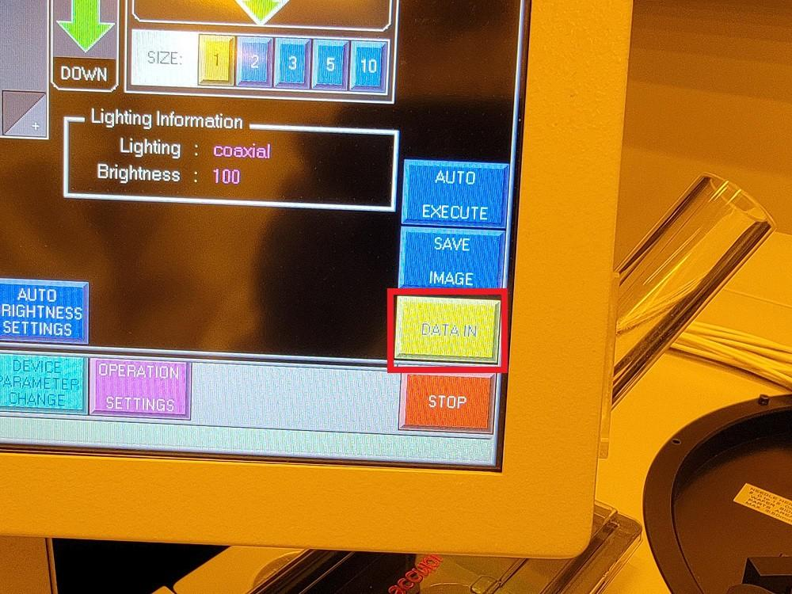
    - Press “Clear screen” when prompted with “STOP AFTER AUTO NEEDLE HEIGHT SETTING DONE” (Figure 8ai).

Figure 8ai: Clear Screen
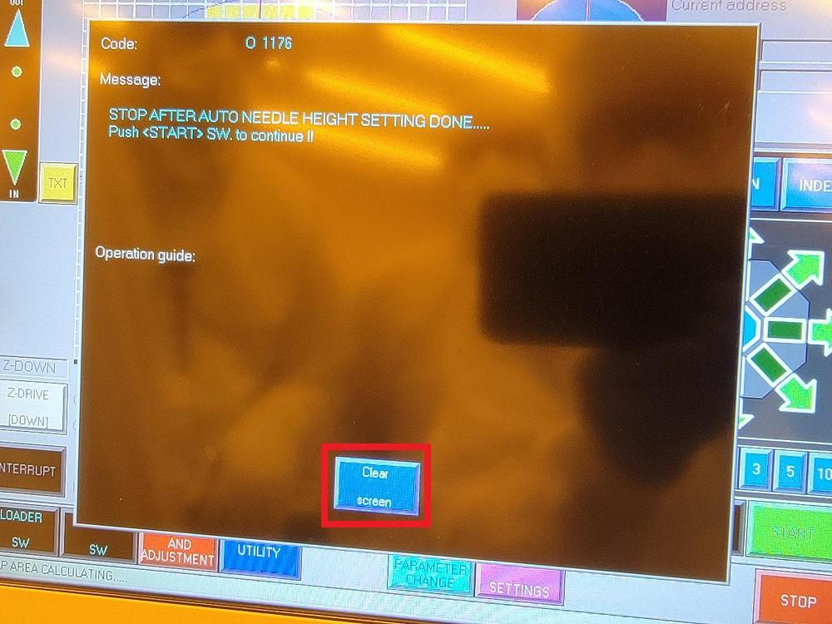
    - Verify the CARD RELATIVE Z HEIGHT and Probing Overdrive (Figure 8aj).

NOTE: These are program specific settings. Contact Test/Metrology Engineer for correct settings.

Figure 8aj: Verify Probe Settings
Atomica Corp. EOI-249
Operation of PROBE08 (Accretech UF200R) and PROBE02 (Electroglas 2001X) Version: 4.0

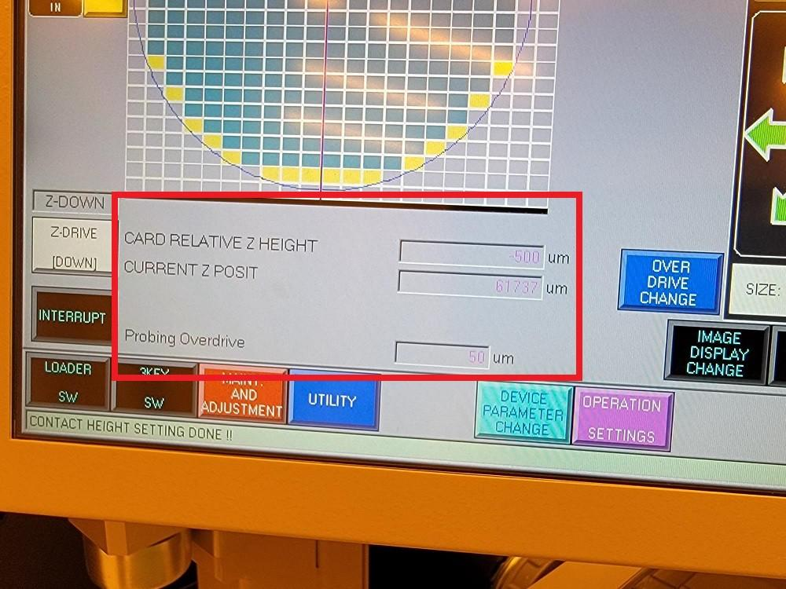
    - Press “START” (Figure 8ak).

Figure 8ak: START
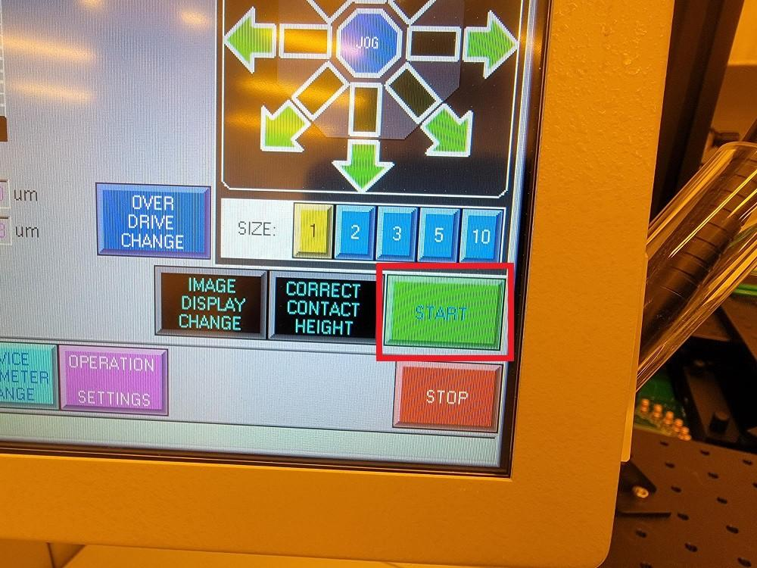
    - “Probing” will be displayed in the bottom left corner of the screen (Figure 8al).

Figure 8al: Ready for Probing
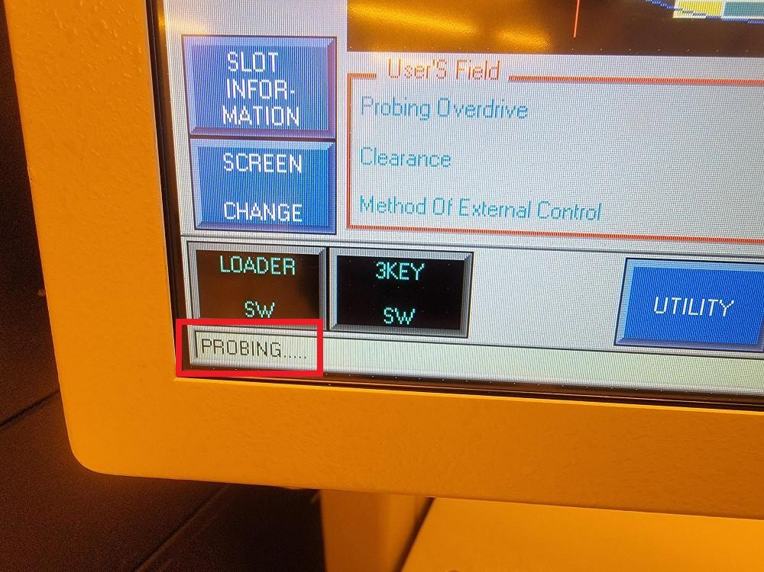
    - Move to the PROBE08 desktop PC and launch the Atomica Tester executable. (Figure 8am).

NOTE: Login to the PC with the following credentials (User: Atomica, Password:
Atomica Corp. EOI-249
Operation of PROBE08 (Accretech UF200R) and PROBE02 (Electroglas 2001X) Version: 4.0

Engineer2022)

Figure 8am: Shortcuts to Probing Executables at Top Right of Desktop
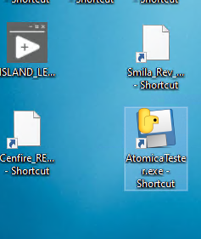

    - Verify instruments are connected, verify working directory is correct. Load program specific ATA folder (e.g. Lamp, Maddy, etc.) (Figure 8an).

Figure 8an: Load ATA folder
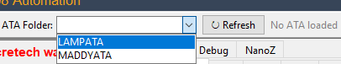

    - Go to recipe tab, check that correct probe card is selected. Check that the recipe is correct for your probe card. (Figure 8ao).

Figure 8ao: Recipe tab, Match the probe card with the label on the physical card.

Atomica Corp. EOI-249
Operation of PROBE08 (Accretech UF200R) and PROBE02 (Electroglas 2001X) Version: 4.0

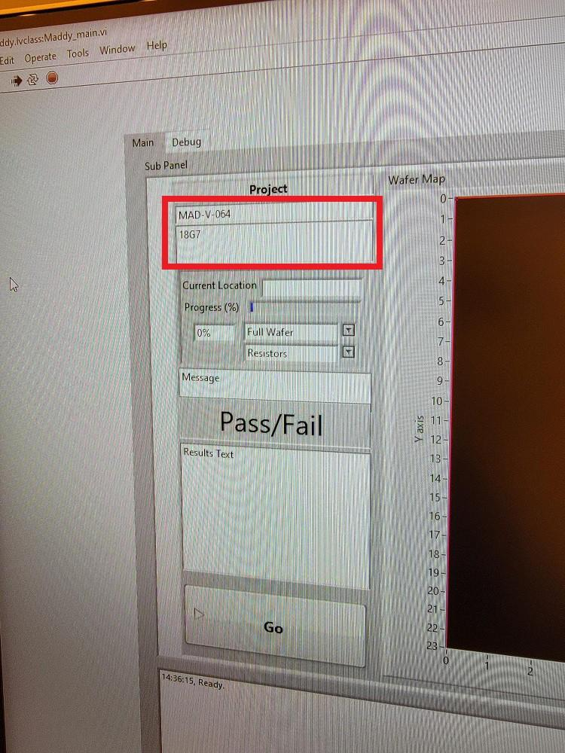
    - Go to the Run tab, load the recipe. Press Full die to test all dies, Press Test die to test only 5 dies or any set of selected ones. Note: The prober will not run and throw an error unless it says “Probing” on the bottom left. (Figure 8ap).

Figure 8ap: Press Full or Test Die to Start Probing Sequence
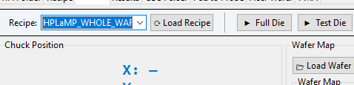
    - Probing commences.
    - Once probing has completed, press “UNLOAD” under the “Run” tab (Figure 8aq).

Figure 8aq: UNLOAD
Atomica Corp. EOI-249
Operation of PROBE08 (Accretech UF200R) and PROBE02 (Electroglas 2001X) Version: 4.0

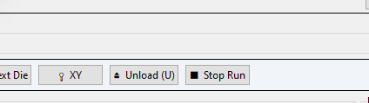
    - Open the Front Access Door and remove the wafer from the chuck.

NOTE: For directions on unloading wafers using CASSETTE, refer to steps following
8.4.13 below.

    - Close the Front Access Door and press “START” on the Accretech UF200R interface (Figure 8ar).

Figure 8ar: START for Removing Wafer
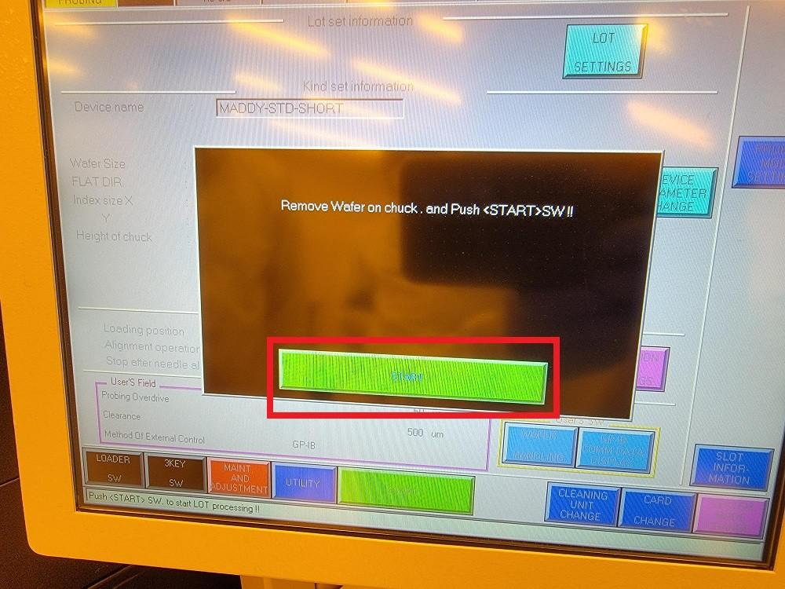
    - Press “Clear screen" when prompted with ”DONE!!" (Figure 8as).

Figure 8as: DONE!!
Atomica Corp. EOI-249
Operation of PROBE08 (Accretech UF200R) and PROBE02 (Electroglas 2001X) Version: 4.0

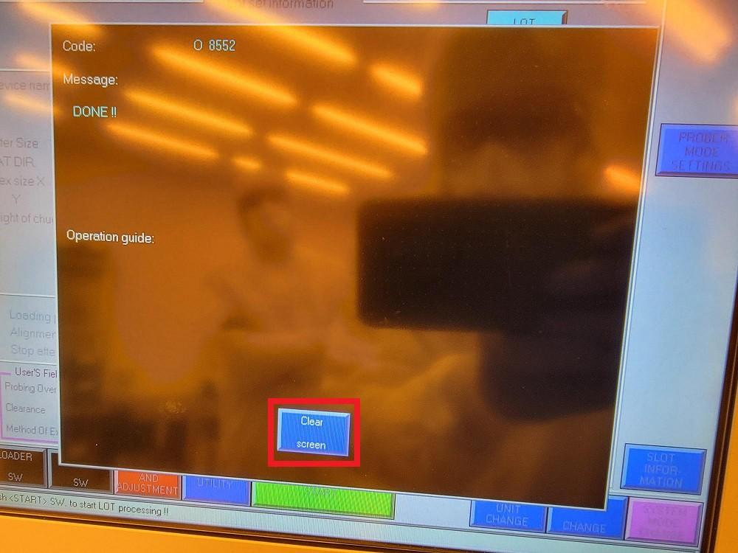

Cassette Loading and Unloading
    - Press “OPERATION SETTINGS” (Figure 8at).

Figure 8at: OPERATION SETTINGS

    - Verify the “CASSETTE” Loading/Unloading position is highlighted and press “ENT” (Figure 8au).

Figure 8au: Verify CASSETTE Loading/Unloading Position
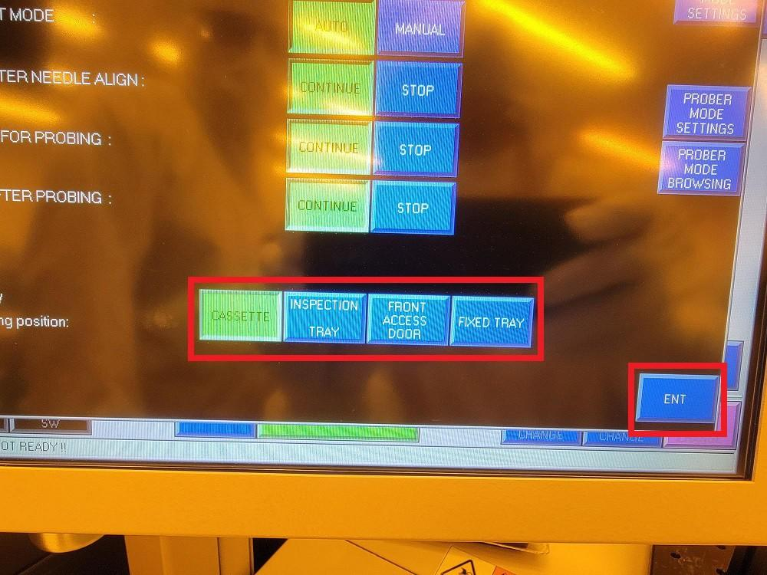
Atomica Corp. EOI-249
Operation of PROBE08 (Accretech UF200R) and PROBE02 (Electroglas 2001X) Version: 4.0

    - Press “LOADER SW” (Figure 8av).

Figure 8av: LOADER SW
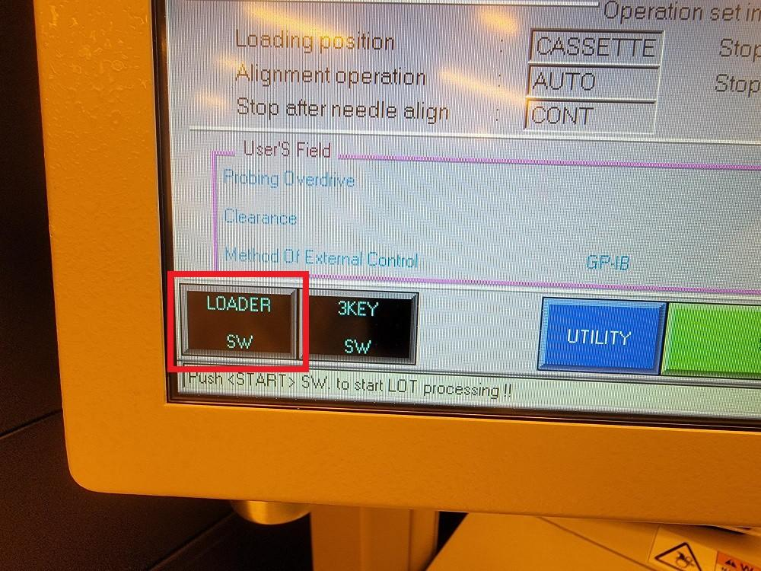
    - Press “TRAY LOCK/UNLK 1” (Figure 8aw).

Figure 8aw: TRAY LOCK/UNLK 1
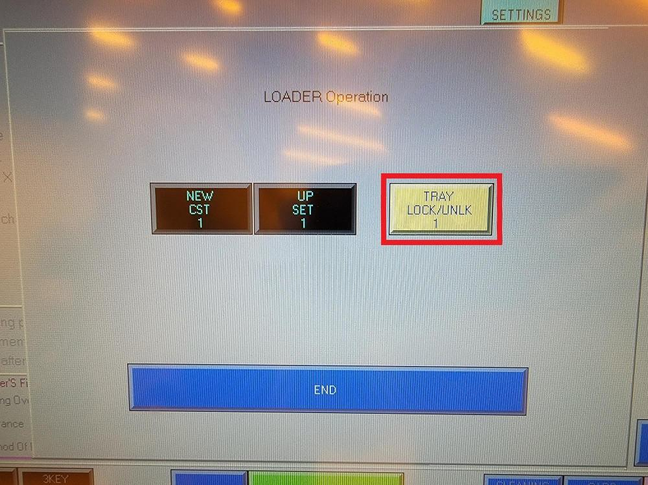
    - Open the cassette tray (Figure 8ax).

Figure 8ax: Open Cassette Tray
Atomica Corp. EOI-249
Operation of PROBE08 (Accretech UF200R) and PROBE02 (Electroglas 2001X) Version: 4.0

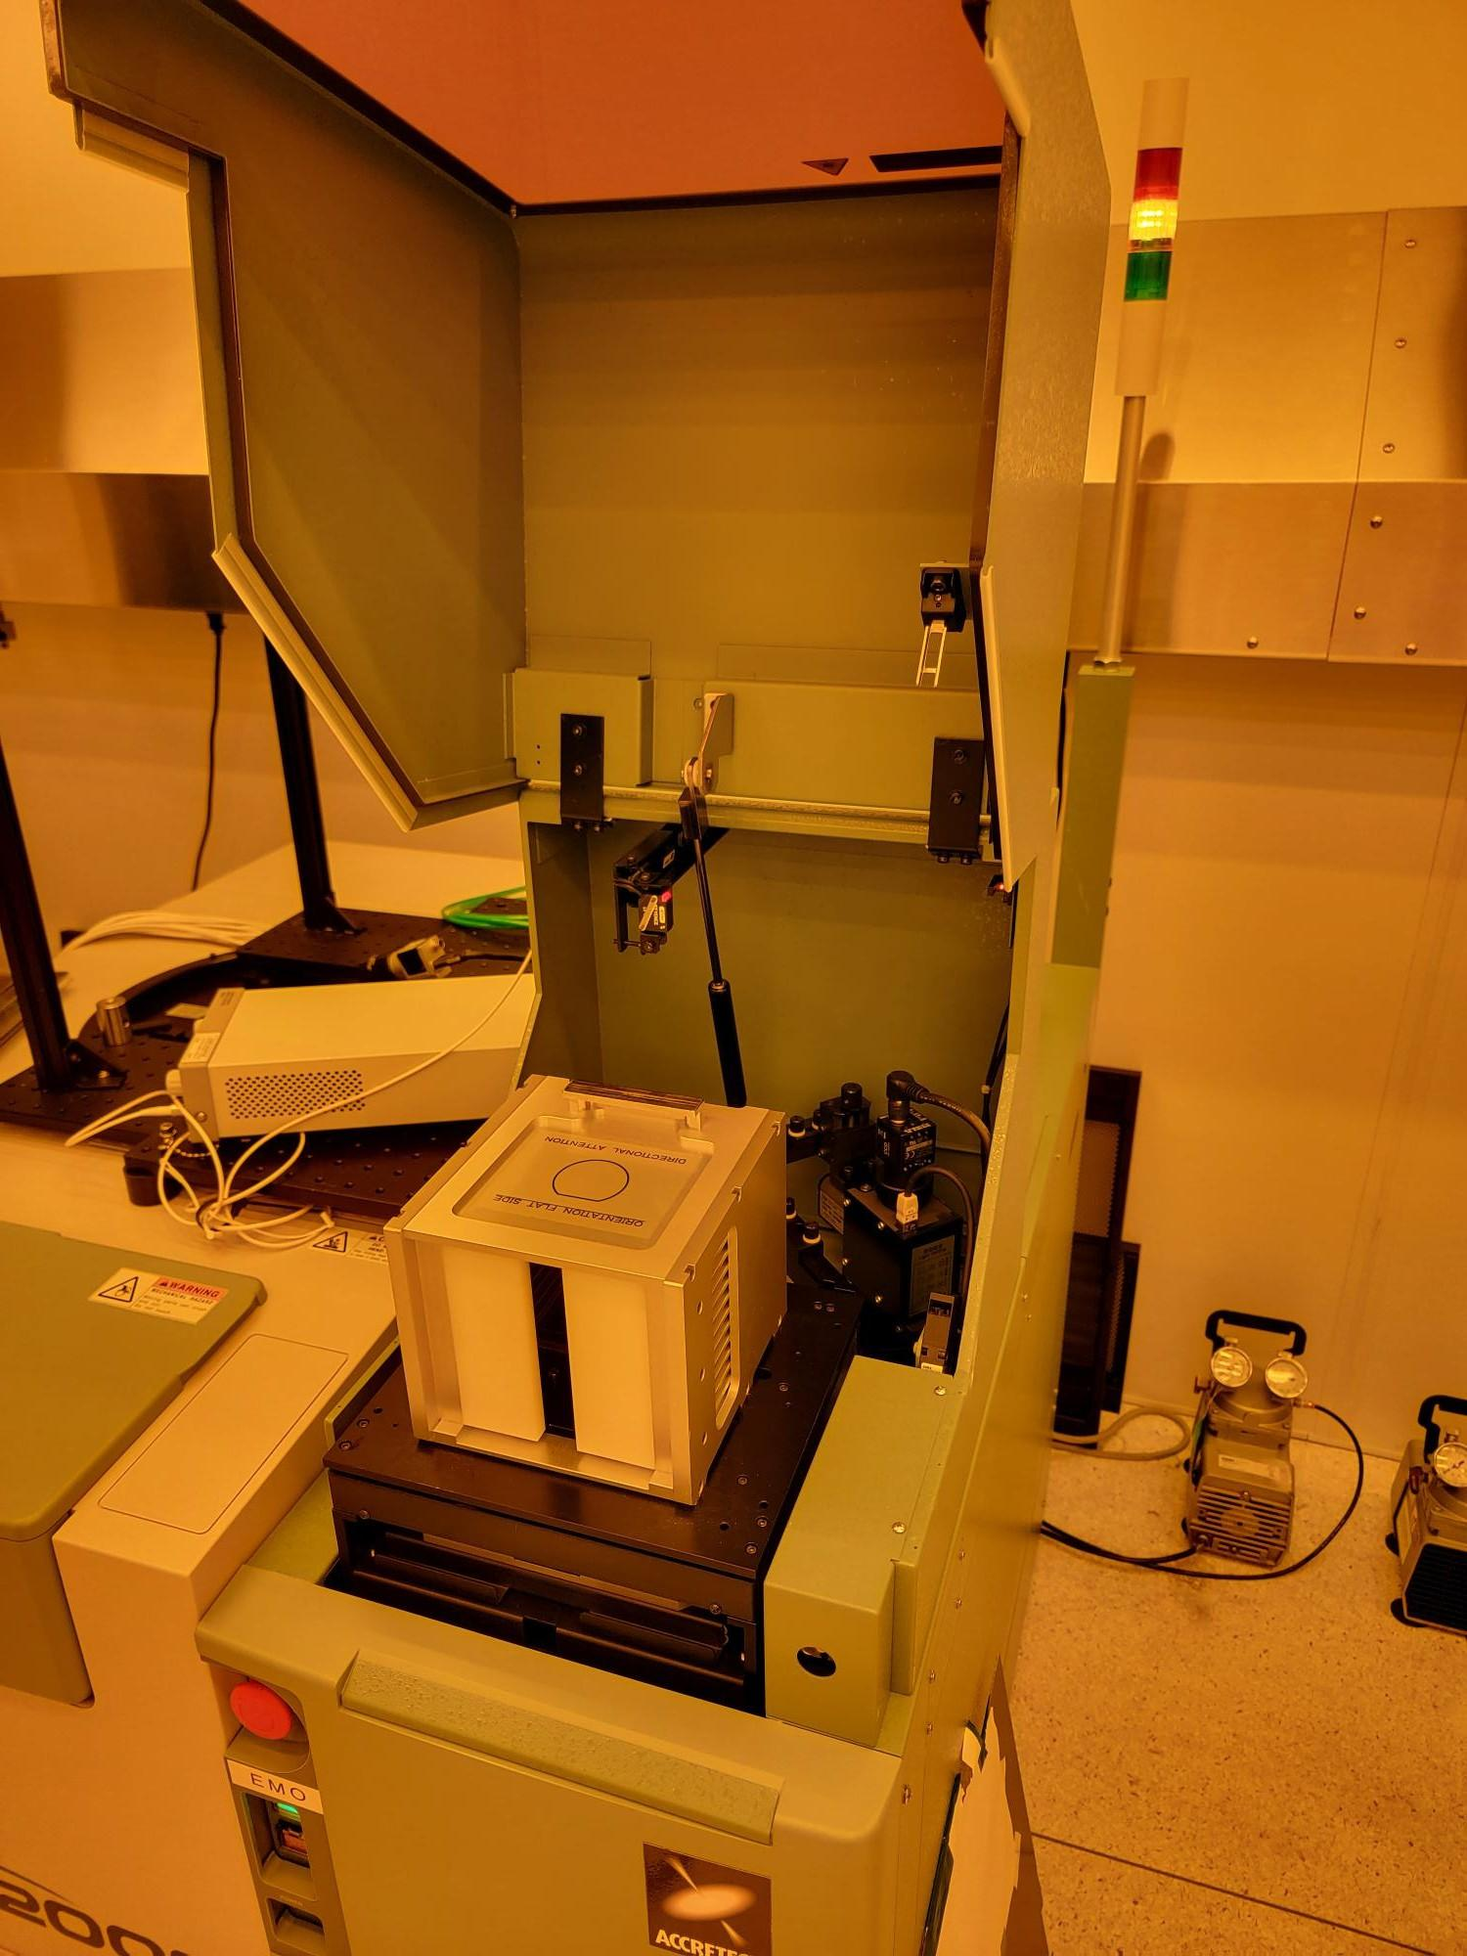

    - Remove the PROBE08 cassette and load wafers into consecutive slots starting from the slot closest to the H-bar. Load wafers so that the sides to be probed are facing away from the H-bar (Figure 8ay).

Figure 8ay: Wafer Loaded into Slot Closest to H-bar
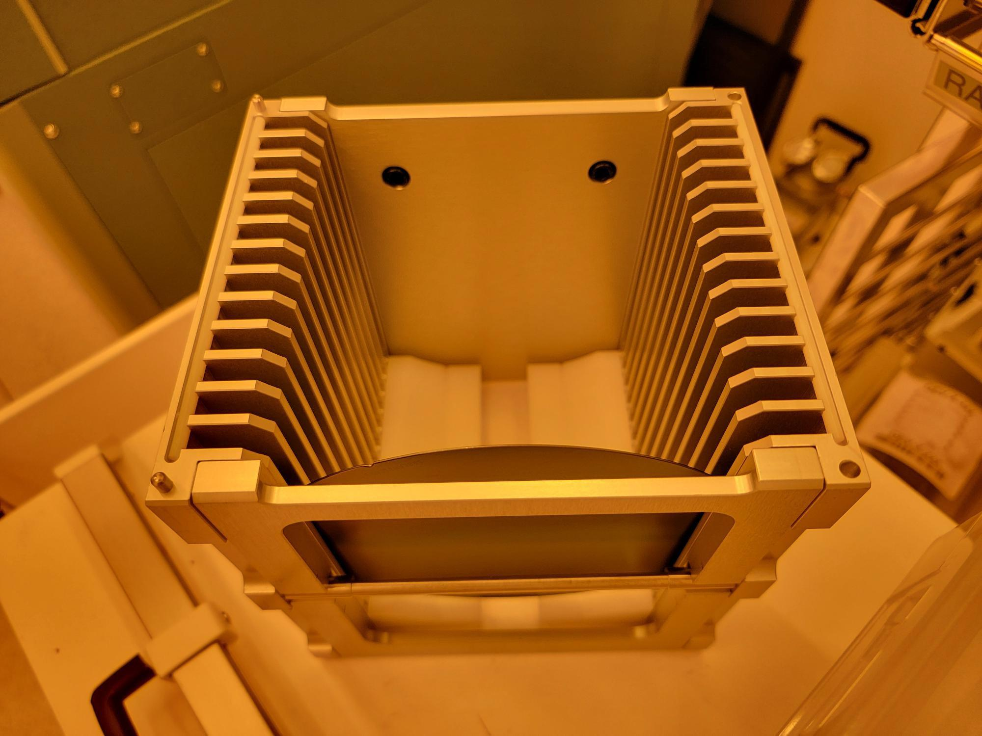
    - Load the PROBE08 cassette into the cassette tray so that the H-bar is facing down and fits within the groove (Figure 8az).

Figure 8az: Cassette Loaded into Tray
Atomica Corp. EOI-249
Operation of PROBE08 (Accretech UF200R) and PROBE02 (Electroglas 2001X) Version: 4.0

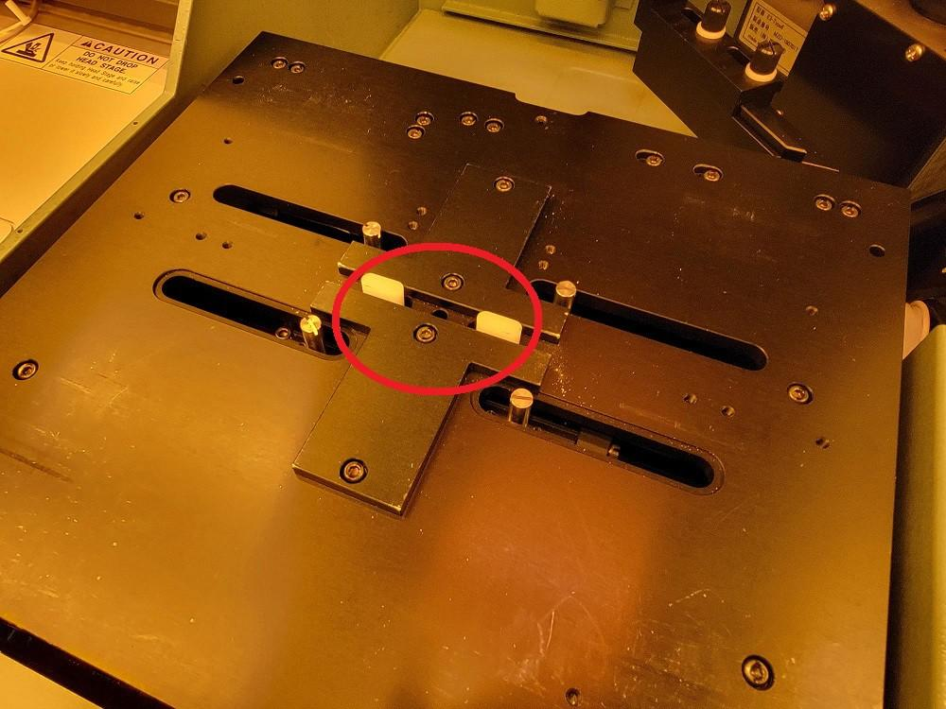
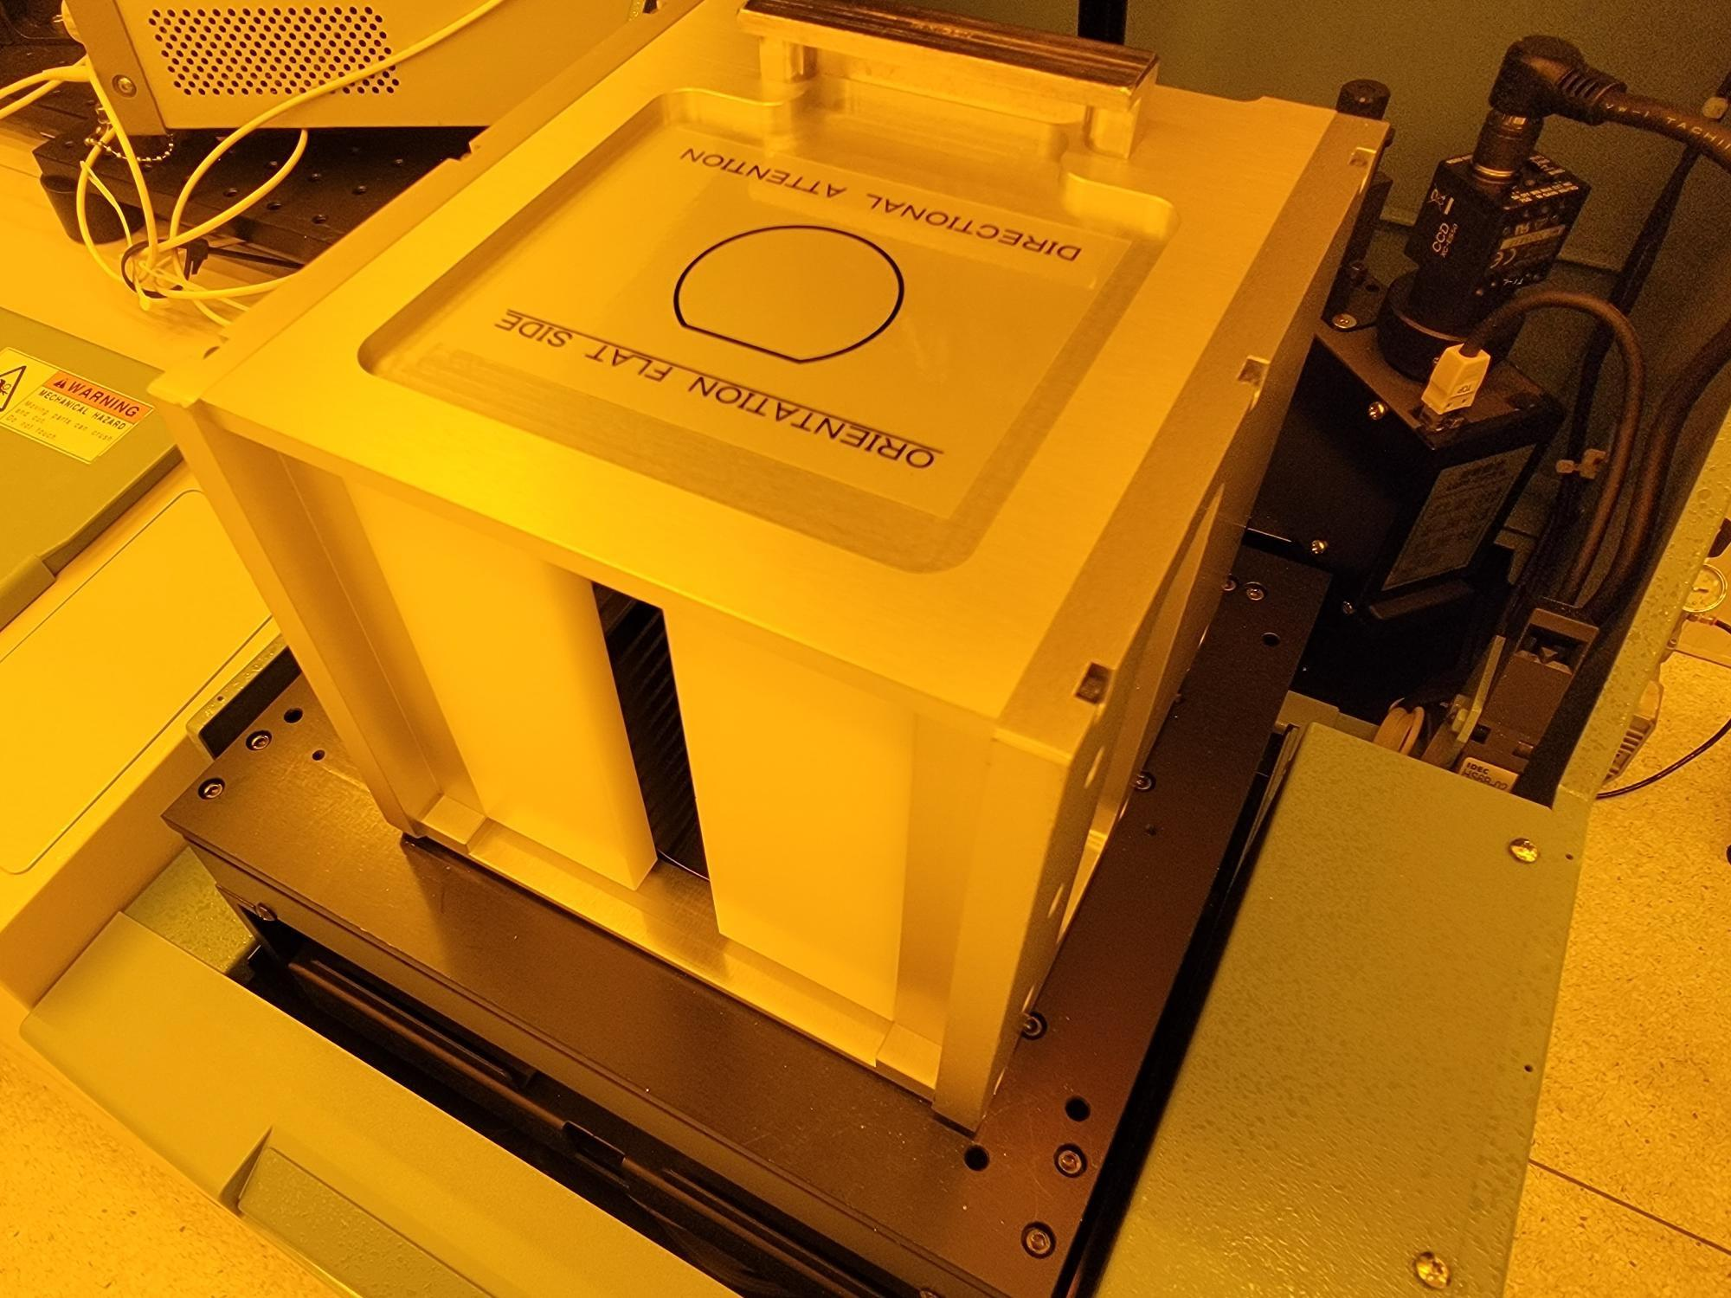

    - Close the cassette tray.
    - Press “TRAY LOCK/UNLK 1” (Figure 8ba).

Figure 8ba: TRAY LOCK/UNLK 1
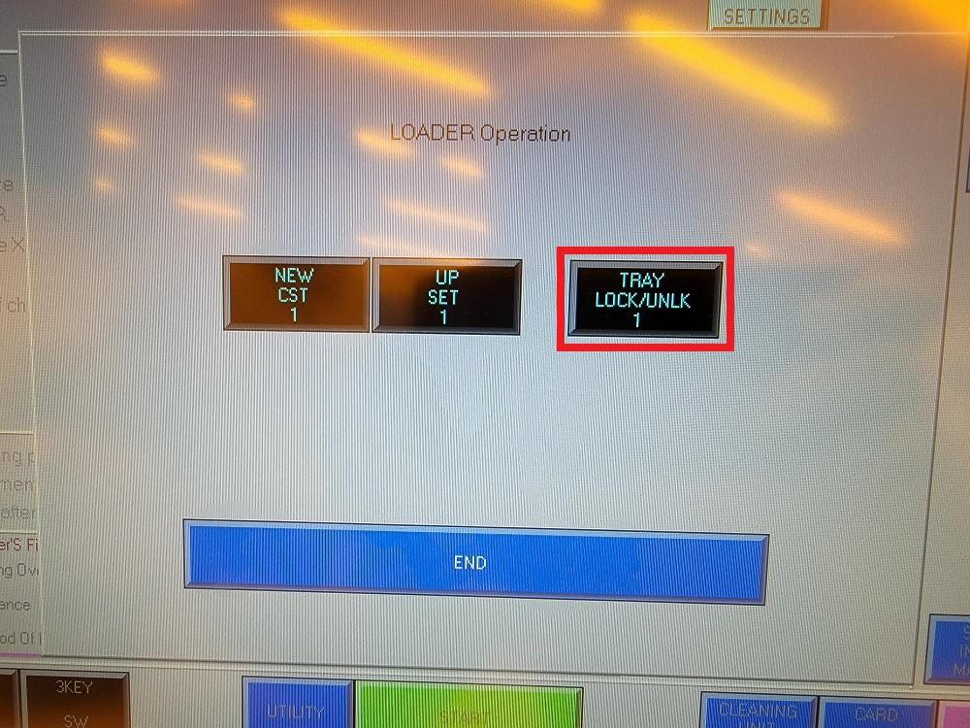
    - Press “NEW CST 1” (Figure 8bb).

Figure 8bb: NEW CST 1
Atomica Corp. EOI-249
Operation of PROBE08 (Accretech UF200R) and PROBE02 (Electroglas 2001X) Version: 4.0

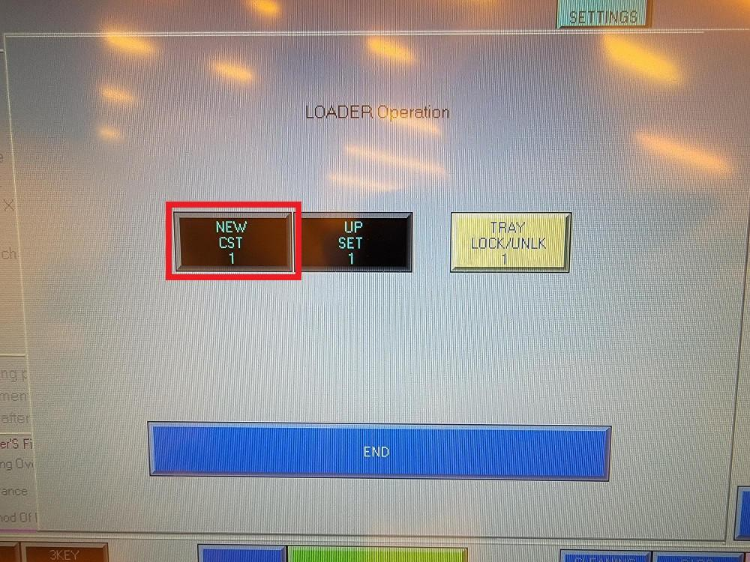
    - The cassette will lower into the tool and a wafer will be loaded.
    - Proceed with probing by following procedure starting at step 8.3.8 above.
    - After probing is completed, press “Clear screen” when prompted with “DONE !!” (Figure 8bc).

Figure 8bc: Clear Screen
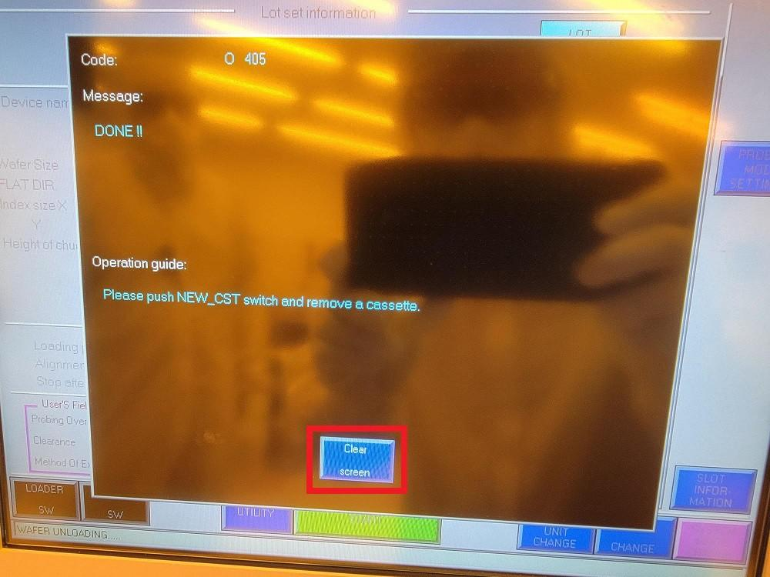
    - Press “NEW CST 1” (Figure 8bd).

Figure 8bd: NEW CST 1

Atomica Corp. EOI-249
Operation of PROBE08 (Accretech UF200R) and PROBE02 (Electroglas 2001X) Version: 4.0

    - Press “LOADER SW” (Figure 8be).

Figure 8be: LOADER SW

    - Press “TRAY LOCK/UNLK 1” (Figure 8bf).

Figure 8bf: TRAY LOCK/UNLK 1

    - Open the cassette tray and remove the wafers. Close the cassette tray with the empty PROBE08 cassette loaded inside (Figure 8bg).

Figure 8bg: Leave Cassette Inside Tray
Atomica Corp. EOI-249
Operation of PROBE08 (Accretech UF200R) and PROBE02 (Electroglas 2001X) Version: 4.0

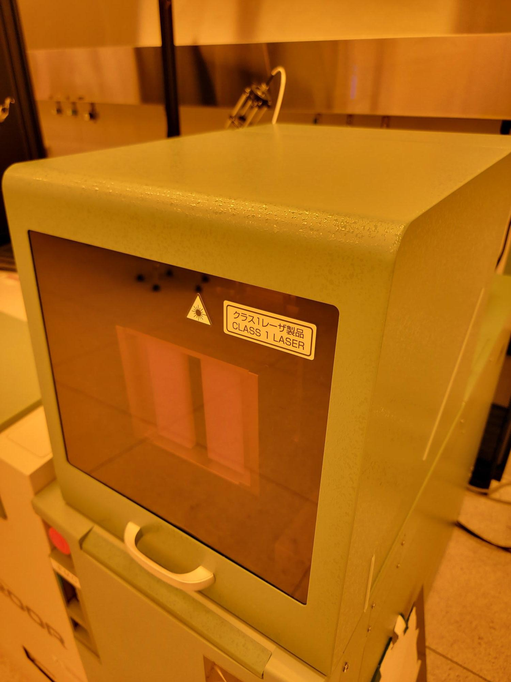

    - Press “TRAY LOCK/UNLK 1” (Figure 8bh).

Figure 8bh: TRAY LOCK/UNLK 1

    - Press “END” (Figure 8bi).

Figure 8bi: END
Atomica Corp. EOI-249
Operation of PROBE08 (Accretech UF200R) and PROBE02 (Electroglas 2001X) Version: 4.0

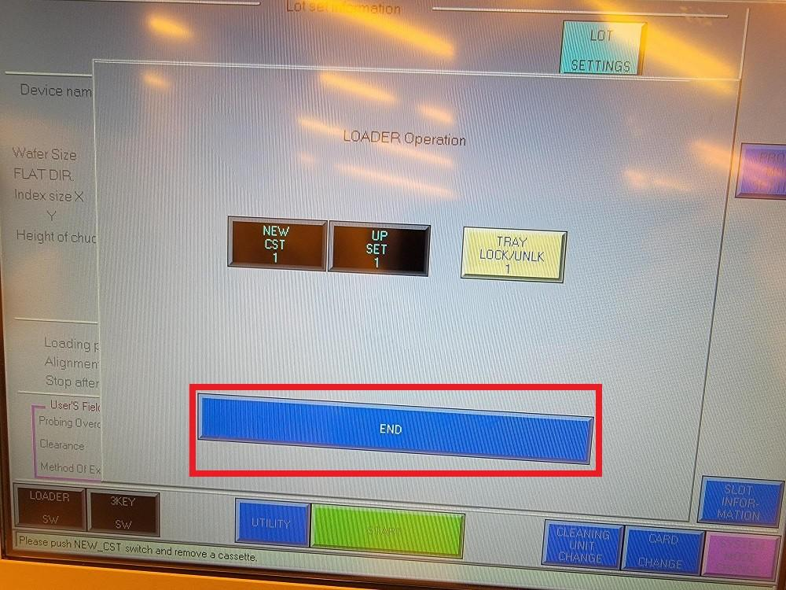

Qualiﬁcation Procedure
Release Qualification / Gage Monitor:
  - Install the Maddy probe card per Section 8.2 Changing Probe Card.
  - Load gage wafer MAD-X-008-13B3 using the front access door per Section 8.3 Starting Probe Routine until step 8.3.18.
  - Open executable and load the Maddy ATA folder, then load the Maddy TL recipe for the MADX probe card (which should be installed already) (Figure 9a).

Figure 9a: When Ready to Probe, Run the MADDY LabVIEW Executable
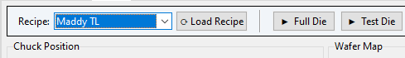
  - In the results tab, enter the LOT ID (MAD-X-008) and WAFER ID (13B3).
  - Press “Test DIE” to start probing. (Figure 9b).

Figure 9b:
Atomica Corp. EOI-249
Operation of PROBE08 (Accretech UF200R) and PROBE02 (Electroglas 2001X) Version: 4.0

  - Once probing is complete, unload the wafer per steps 8.3.23 - 8.3.26.
  - Go to results tab and save csv. Verify the data file saved at default file path \\prober\ETL\RAWDATA\PROBE08 (Figure 9c).
Atomica Corp. EOI-249
Operation of PROBE08 (Accretech UF200R) and PROBE02 (Electroglas 2001X) Version: 4.0

Figure 9c: Gage Wafer Data Files on Prober
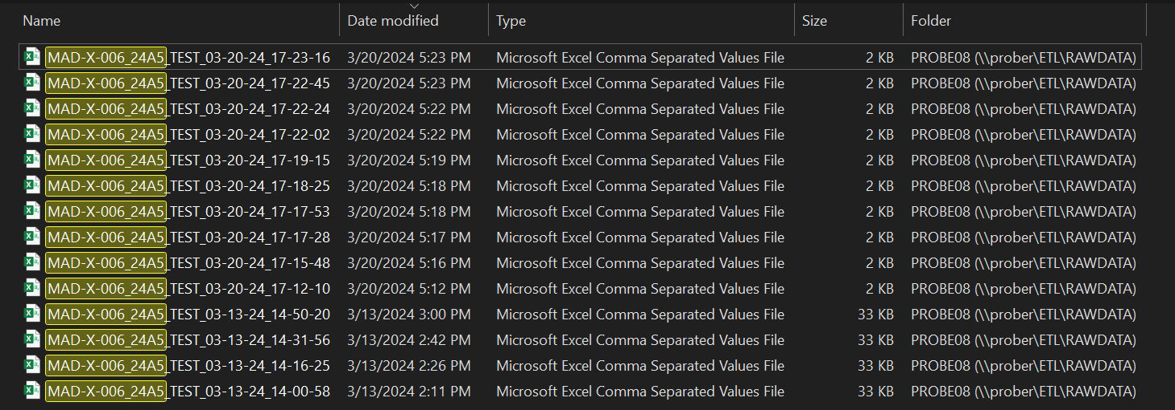
  - Save a copy of the data file to C:\Data on a lab PC. Rename the file as “savedatahere.csv”.
  - Open SPC Chart CC-02329 PROBE08 (navigate to IMT Equip/Proc/IQA Mon => GAGES => CC-02329 PROBE08). Press the “Add Data” button to upload data from the data file in C:\Data. Verify the data then press “Save”.
  - Use data to verify the process is in control. Put PROBE08 down in MES if data is out of control limits.

Records

  - \\prober\ETL\RAWDATA\PROBE08
  - SPC CC-02329 PROBE08

Attachments
Atomica Corp. EOI-249
Operation of PROBE08 (Accretech UF200R) and PROBE02 (Electroglas 2001X) Version: 4.0

Electroglas 2001X (PROBE02) Operation
[Insert screenshot here]
Figure: PROBE02 Electroglas 2001X
This section covers operating PROBE02, the Electroglas 2001X manual/semi-automatic prober, through the GUI. It assumes the reader is already familiar with the general GUI layout described in the Full GUI Manual, and focuses on what is different about Electroglas compared to Accretech.

Key Differences From Accretech
• No onboard wafer map. The Accretech UF200R tracks its own wafer map internally and can be commanded to step to a die by absolute coordinate or walk the whole map on its own. The Electroglas 2001X has no equivalent - wafer mapping is disabled on this machine, so the GUI itself is responsible for tracking where the chuck physically is.
• The die grid depends entirely on where the datum was set. Every time the operator re-establishes the chuck's starting position (Set First Die / FD, or the GUI's own "Chuck Is Set" anchor in NanoZ mode), the software's idea of "die (0,0)" moves to wherever the chuck physically is at that moment. There is no fixed physical origin the way there is on Accretech.
• No cassette automation. Wafers are loaded and unloaded manually; there is no automated cassette-stepping equivalent to Accretech's.
• Motion is relative, not absolute. The prober is stepped with relative die (MD) or relative-micron (MM) moves rather than commanded to an absolute coordinate directly, and the software verifies the chuck's real position before and after every move rather than assuming a commanded move landed correctly.

Safety
[Insert screenshot here]
Figure: Electroglas mechanical hazards / EMO
The same general mechanical hazards described for the Accretech UF200R apply to the Electroglas 2001X - moving chuck, head stage, and cassette hardware. Be aware of pinch points during any motion.
WARNING: The Electroglas 2001X does NOT reliably stop itself from being driven off the platen. On this specific machine, a run of consecutive relative moves in the same direction were all acknowledged as successful by the prober while actually driving the chuck tens of millimeters past the edge of travel before finally being refused - only the single large move back was rejected. The GUI enforces its own software travel guards (a cap on the size of any single move, and an optional absolute envelope once a trustworthy datum is established) specifically because the prober itself cannot be relied on to do this. Do not disable or bypass these guards, and always re-establish the datum after any hand/joystick motion before resuming an automated move sequence.

Equipment/Tooling
• PROBE02 Electroglas 2001CX/2001X Semi-Automatic Prober
• KEYSIGHT 2400 Source Meter (or the Keithley 2636B, depending on bench configuration)
• KEYSIGHT 3458A Digital Multimeter
• AGILENT 6634B Power Supply
• Program-specific probe cards

Establishing a Datum
[Insert screenshot here]
Figure: Establishing a datum / Set Initial anchor
Before any automated or software-tracked motion can be trusted, the chuck's real position must be tied to a known die. Manually align the chuck on a die whose identity is known (per the loaded wafer plan/recipe), then set that as the reference point:
• On the normal Run tab's PMA-driven flow, this is the "Set Initial" anchor - confirming the current chuck position against a known wafer/touchdown position before any automated relative stepping begins.
• In NanoZ mode, this is the "⚓ Chuck Is Set" control - pick the die the chuck is physically on from the dropdown and press it once confirmed.
WARNING: The datum must be re-established after ANY motion that did not go through one of the GUI's own tracked move commands - a joystick nudge, a manual jog, or a prober front-panel command. The software has no way to detect that its remembered position no longer matches reality, and computing a move from a stale datum has caused a confirmed out-of-bounds move on real hardware.

Running a Recipe — MD vs MM Motion Modes
[Insert screenshot here]
Figure: PMA Run tab, motion-mode selector
Once a datum is established, the Run tab steps between touchdowns using one of two motion modes, selectable per recipe/run:
• MD (die mode) — the default. Moves are commanded in relative die counts; the prober itself is responsible for converting a die count into physical distance, using its own configured die pitch. This is the better-verified mode and should be preferred unless there is a specific reason to use MM.
• MM (micron mode) — moves are commanded in relative microns, computed directly from the recipe's own coordinate data, with no dependency on the prober's die-pitch setting. This exists to reproduce how some legacy recipes were originally run, but its underlying counts-per-micron conversion factor was determined empirically on the bench rather than being a documented machine constant, and why that factor is what it is remains unconfirmed. MD stays the safer default until that is fully explained.
Whichever mode is selected, the software verifies the chuck is really where it expects BEFORE sending any move (catching a stale datum before it can cause a wrong move), and checks the result AFTER the move completes (catching a refused or incomplete move before continuing to the next touchdown). A move larger than the configured per-hop cap is automatically split into multiple smaller hops rather than sent as one large command.

Known Limitations
• No automated whole-wafer or cassette walk. Touchdowns are stepped through via the recipe's own saved list, one at a time, with the software verifying position at every step - there is no native "walk the entire wafer" command equivalent to Accretech's.
• Jog direction labels are only confirmed for a bottom-right (load-position) datum. Once a centre datum has been established (Set First Die at wafer centre rather than at load position), which physical direction is +X/+Y on this machine has not been independently re-confirmed - verify by eye, or against a position readback, before trusting the on-screen jog arrow labels after re-zeroing at a centre datum.

Tips and Troubleshooting
[Insert screenshot here]
Figure: example error messages / dialogs
This section collects practical guidance and known failure modes encountered operating both systems through this GUI, along with what to check or do about each one.

General
• Always set an explicit compliance/limit value on a force step - a blank Limit field does not mean "unlimited safely", it means the instrument keeps whatever compliance it last had, which can be far higher than intended.
• Leave the Shortcut ("Don't resend configs") checkbox off unless a specific recipe/instrument combination has been re-verified with it on. It has previously been found to skip re-sending compliance limits along with everything else, letting a DUT run at an uncontrolled compliance after the first touchdown of a run.
• If the Measure button appears to "do nothing" and logs a stopped-before-step-1 message, this used to be a real bug where a previous Stop Run press left an internal flag set that blocked every later Measure press until the app was relaunched. It has since been fixed - Measure now resets that flag itself - but if it is ever seen again on an older build, restarting the application clears it.
• On a Minor Moves recipe, the plain Measure button only ever tests the FIRST die of a shot - it has no run context to walk the shot's remaining dies, and will stop there with a message explaining that, rather than measuring further dies. This is intentional; use a real run (Full Die / Test Selected / ▶ Run) to walk an entire shot.
• If a low-signal measurement (a few hundred microvolts or less) looks noisy or inconsistent between otherwise-identical dies, check the recipe's averaging (Avg Count) and NPLC settings - a single fast, unaveraged reading of a very small signal can be dominated by noise rather than reflecting a real difference in the DUT.
• Do not edit export formats (Results tab → formats) while another GUI session on the same station is already running - a running session holds its own copy of the format list in memory and can silently overwrite a file edit made from outside it when it next saves. Close/restart the session before editing formats, or make the edit and then reload rather than editing live.

Accretech-Specific
• If a recipe uses a channel (A/B) that the active bench's switch wiring does not actually have wired for the selected instrument, the Recipe tab's channel dropdown will not offer it - if an older recipe was built for a different bench's wiring (for example a two-channel SMU's channel B) and is then run on a bench with a single-channel SMU, re-check and correct the channel/connections before running, since the recipe's own saved value may no longer match real wiring.
• Cassette automation remembers and repeats the same run mode (Full Die / Test Selected / ▶ Run) that the first wafer in the cassette was actually started with, including the exact Test Selected site list if that was the mode used - it does not fall back to Full Die for later wafers.

Electroglas-Specific
• Re-anchor (Set Initial / Chuck Is Set) any time the chuck has been moved by hand, joystick, or a prober front-panel command since the last anchor - the software cannot detect a stale datum on its own, and a move computed from one can send the chuck to the wrong physical die.
• Prefer MD (die mode) over MM (micron mode) unless there is a specific, understood reason to use MM - see the motion-mode discussion above.
• The Electroglas driver has no cassette automation and no fully automated whole-wafer walk in NanoZ mode - step through the recipe's touchdown list manually.
• Jog arrow labels (in Prober Debug) were only measured against a bottom-right load-position datum. After re-zeroing at a centre datum, verify the physical jog direction by eye before trusting the labels.

